Let It Slide! Worksheet

- Using the spring scale, find the weight of each object by pulling the object straight up into the air. Record the weight (in grams) in the table below.

- Predict which angle would be best to move the rocks up to the top of the pyramid by circling it on the chart below.

Instructions (for each object being measured)
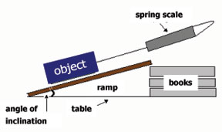
- Use a protractor and books to set your board at a 15-degree angle from the table. This creates a 15-degree inclined plane.
- Hook the object to the spring scale.
- Pull the object up the inclined plane.
- Record the spring scale measurement (in grams).
- Add more books to make your inclined plane
form the next angle in the chart below.

Repeat the steps above for all the degrees of inclined planes listed in the chart below.

- Was it easier to move the object up the inclined plane at the shallower or steeper angle of inclination?

- Which angle required the least amount of pull force on the spring scale to move the object up the inclined plane?

- Was your prediction correct? Why or why not?

- If you were an engineer, which type of ramp would you use to move a heavy object to a high place?

