Solar Water Heater Efficiency Analysis
This worksheet will help you evaluate the performance of your solar hot water heaters.
- During testing, record the following information:
Parameter | Symbol | Value | Units
Total Volume of Water: | V |  | Gallons
Initial Temperature of Water: | T_{i} |  | °F
Total Power of Heat Lamps: | P_{in} |  | Watts
Time Passed: | Δt |  | Hours
Final Temperature of Water: | T_{f} |  | °F

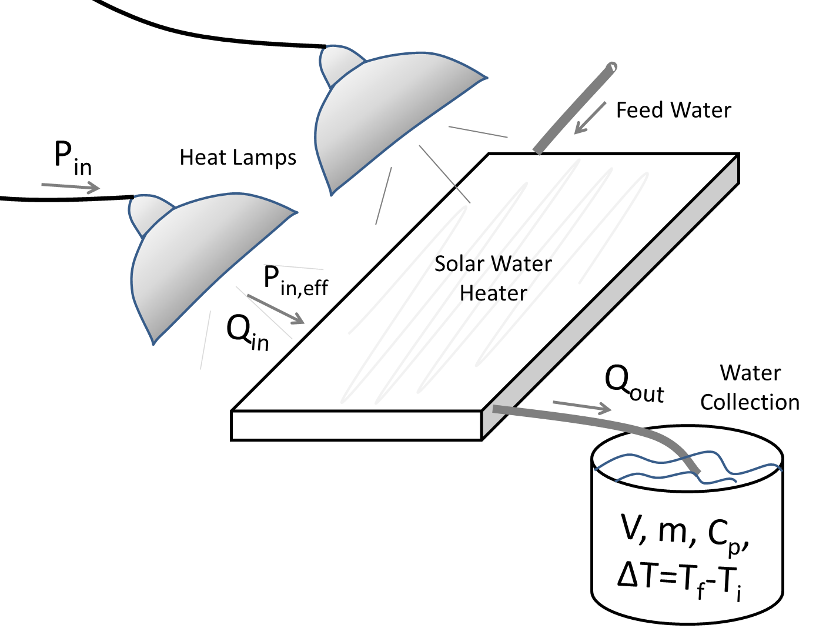
Schematic of solar water heater setup.

To evaluate how well the solar hot water heater performed, we will calculate its EFFICIENCY:
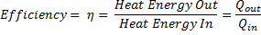

- So first, we’ll need to calculate how much ENERGY was put INTO to the system by finding the total POWER, P_{in}, used by the heat lamps – our simulated sun. The P_{in,} in Watts, is indicated on the light bulbs used:
From above, P_{in} = Watts

Heat lamps are approximately 96% efficient, meaning that they convert 96% of their energy directly into heat. So, we need to figure out how much heat energy came out of the heat lamps based on the power that was used by them.
P_{in,eff} = (96%) * P_{in} = Watts
(P_{in,eff} is the total HEAT POWER coming out of the heat lamps)

Finally, we need to convert HEAT POWER (P_{in}) to HEAT ENERGY (Q_{in}). Power is an instantaneous measurement (like miles per hour for measuring the speed of a car). To get to energy (like total miles traveled by the car), we take the POWER and multiply it by the TIME that the system had that power.
Q_{in} = P_{in,eff} * Δt = Watt-hours
(This is the total HEAT ENERGY that came out of the lamps)

For this exercise, we’ll convert our HEAT ENERGY (Q_{in}) , from “Watt-hours” to units of “BTU” which stands for British Thermal Units. Just like comparing inches to centimeters, BTUs are the American (IP) units and Watt-hours are the international (SI) units. One Watt-hour = 3.41 BTUs.
Q_{in} = Q_{in} (units of Watt-hours) * (3.41 BTU/Watt-hour) = BTUs
(This is the total HEAT ENERGY (Qin) put into the system)
- Next, we need to figure out how much HEAT ENERGY our solar hot water heaters were able to collect (Q_{out}) and use from the heating lamps (our simulated sun)! The equation we will use to calculate how much HEAT ENERGY (Q_{out}) we were able to transfer to our water is:
Q_{out} = m * C_{p} * ΔT
Where, “m” is the total MASS of the water (in lbs), “ C_{p}” is the SPECIFIC HEAT of water and “ΔT” is the TEMPERATURE CHANGE during the test period (in ºF). Let’s calculate each of those values individually first. Remember to keep track of your units!
Let’s start by determining the total MASS (m) of the water that we heated. We recorded the total VOLUME (V) of water in gallons. First, we’ll convert the total VOLUME from gallons to ft³ (cubic feet), knowing that one gallon is equal to 0.1336 ft³.

V = (V in gallons) * (0.1336 ft³/gallon) = ft³

To convert VOLUME (V) to MASS (m), we need to know the DENSITY of water, which is equal to 62.42 lbs/ft³. So,
m = (V in ft³) * (62.42 lbs/ft³) = lbs
(This is the total MASS (m) of water in the system)

Great! Now that we have the MASS (m) of the water, the next term we need to help us calculate the HEAT ENERGY (Q_{out}) collected by our water heaters is the SPECIFIC HEAT ( C_{p} ) of the material being heated, the material being water in this case. SPECIFIC HEAT is a property of a material that describes how much heat energy it takes to warm that material up. Every material has its own specific heat. For water, the specific heat, in IP units, is:
C_{p} of water = 1.0 BTU/(lb-°F)
→This means that it takes 1 BTU of energy to increase the temperature of 1 pound of water by 1°F

Finally, we need to figure out the last term in our equation: the TEMPERATURE DIFFERENCE (ΔT) of the water. This TEMPERATURE DIFFERENCE (ΔT) of the water was achieved by putting HEAT ENERGY (Q_{out}) into the system:
ΔT = T_{f} – T_{i} = °F
(This is the TEMPERATURE DIFFERENCE caused by putting the HEAT ENERGY (Q_{out}) into the system)

Alright! Now, we’re able to plug in our three values to calculate how much HEAT ENERGY (Q_{out}) our water absorbed from the water heater.
Q_{out} = m * C_{p} * ΔT = BTU

- Now that we’ve calculated how much HEAT ENERGY (Q_{in}) was put INTO to the system (our solar water heaters) and how much HEAT ENERGY (Q_{out}) we were able to get OUT of the system in order to increase the water temperature, we can determine the EFFICIENCY our hot water heater:
= %

Record your final results here:
Q_{in} = |  | BTUs
Q_{out} = |  | BTUs
η = |  | %

Provide a written interpretation of these results, using complete sentences:
________________________________________________________________________________________________________________________________________________________________________________________________________________________________________________________________________________________________________________________________________
________________________________________________________________________________________________________________________________________________________________________________________________________________________________________________________________________________________________________________________________________
For example, “Our solar hot water heater was able to heat 2 gallons of water from a starting temperature of 60°F to a final temperature of 106°F after being exposed to two 250 Watt heat lamps for a total of one hour. The efficiency of our hot water heater was 35%, which means that 35% of the energy created by the heat lamps was captured and able to heat the water by 46°F. I would definitely take a shower with that water!”

