Rocket Build Instructions

Instructions

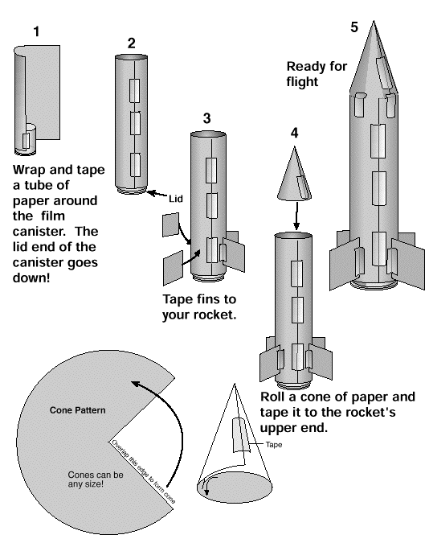
Source: www.spacesociety.org/spaceexpress/Curriculum/film_canisters.html

