Orthographic Drawings Worksheet
Instructions
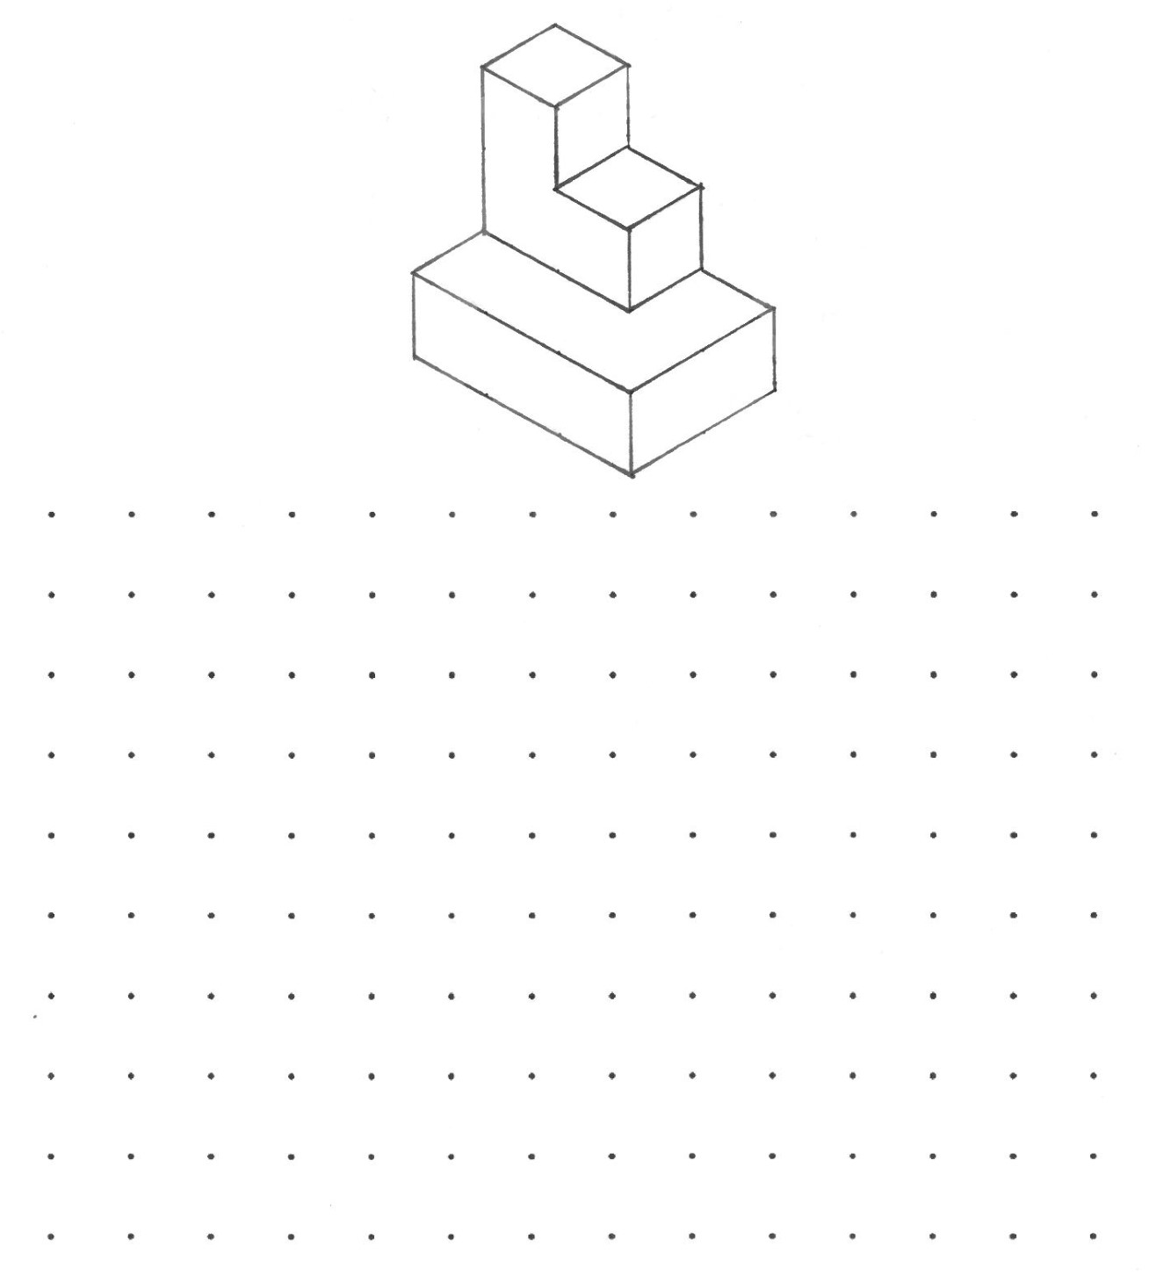
Draw the orthographic projections of the following object.

