Let’s Rotate! Worksheet
Instructions
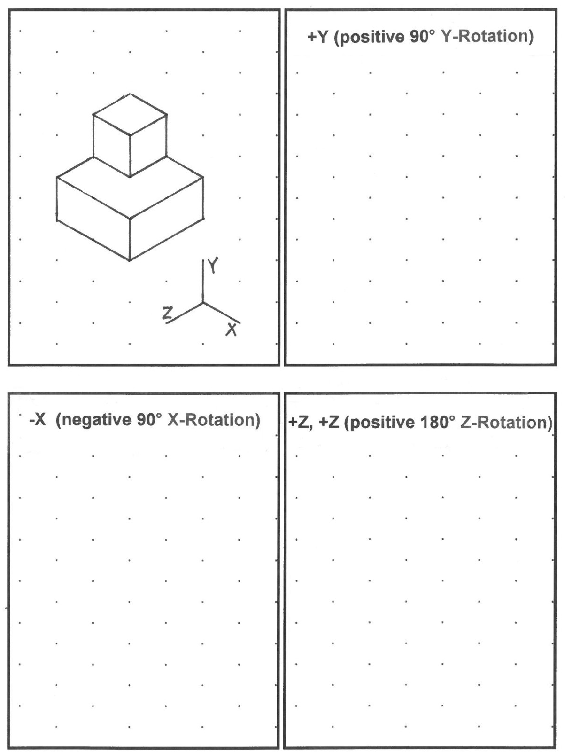
Rotate the orignal block using each of the folloing rotations. The axes are defined below. Use the blank boxes with the triangle-dot paper background to draw your rotations.

