**Rotations Practice Worksheet Answer Key**

**Worksheet Instructions**

* Study how the object in the top line is rotated.
* Picture in your mind what the object shown in the middle line of the question looks like when rotated in the same manner.
* Select your answer from the three options given in the bottom line of the question.

**You have 15 minutes to complete the 15 questions on this practice assignment *Good luck!***



1.

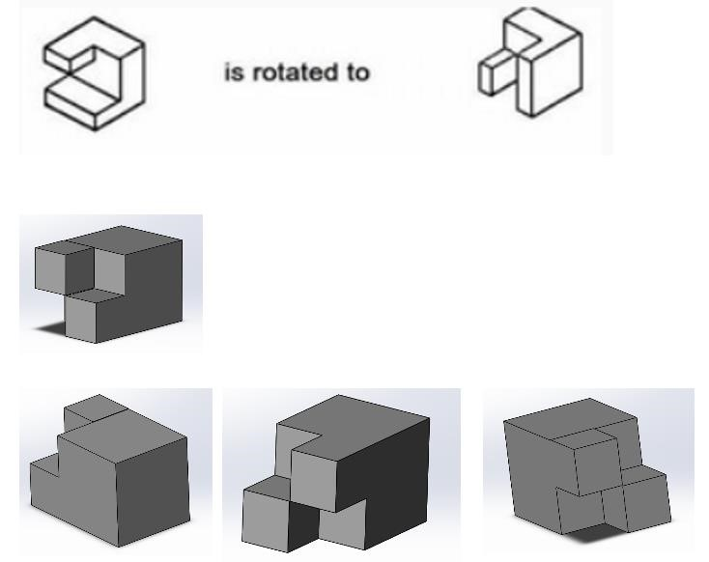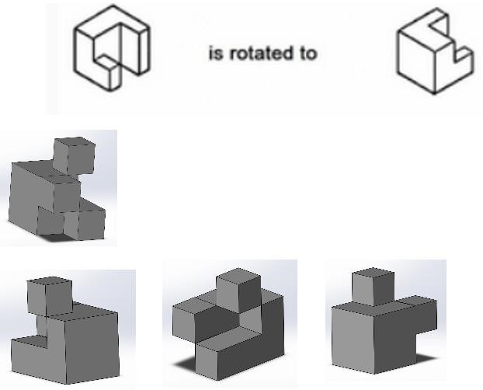

2.

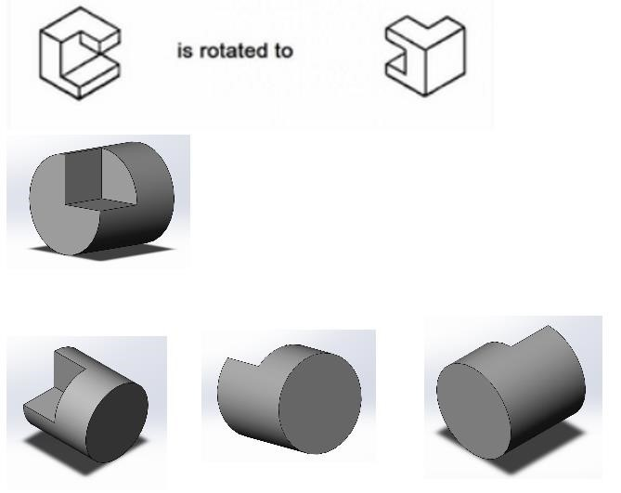

3.

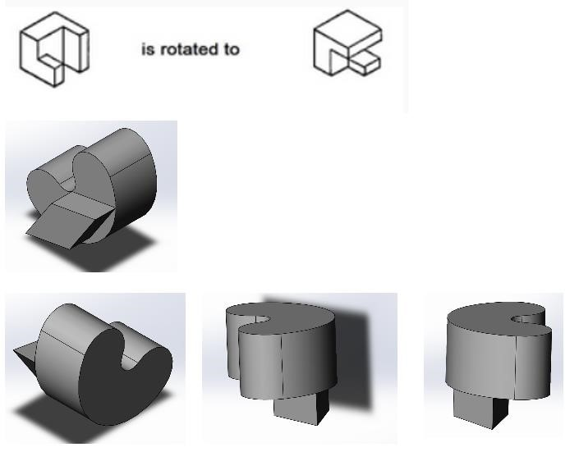

4

.

5.

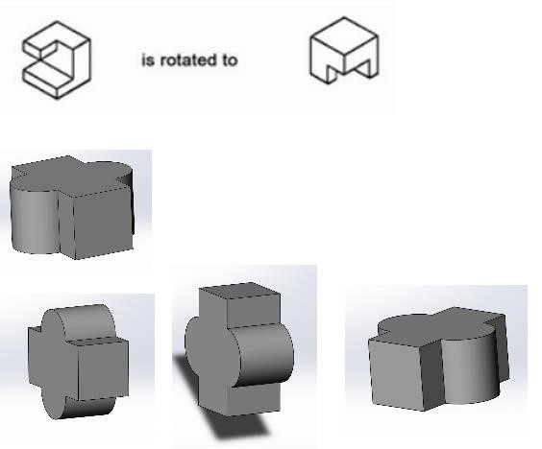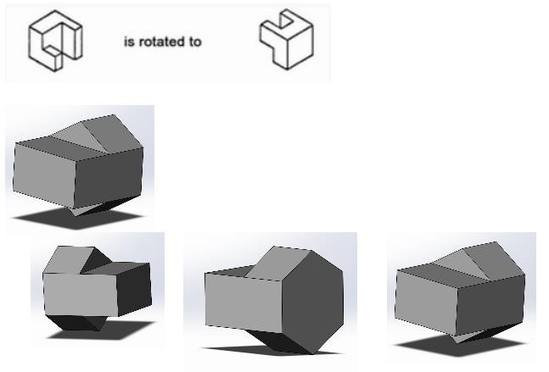

6

.

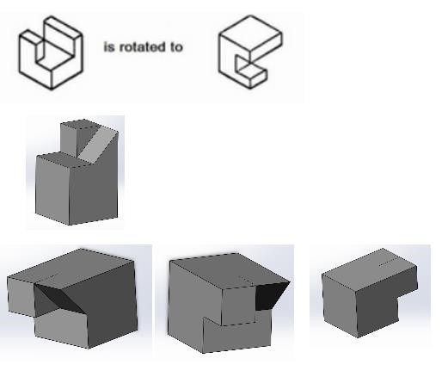

7

.



8

.

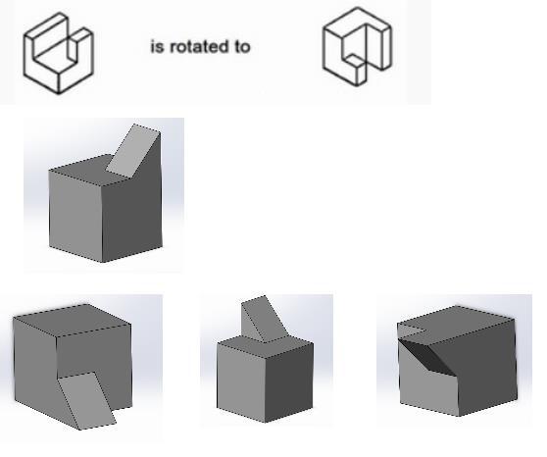

# 9.

# 10.

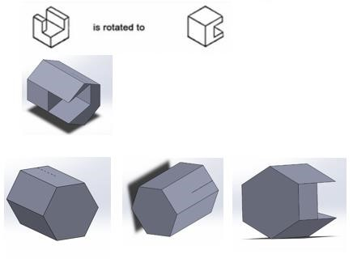

11

.

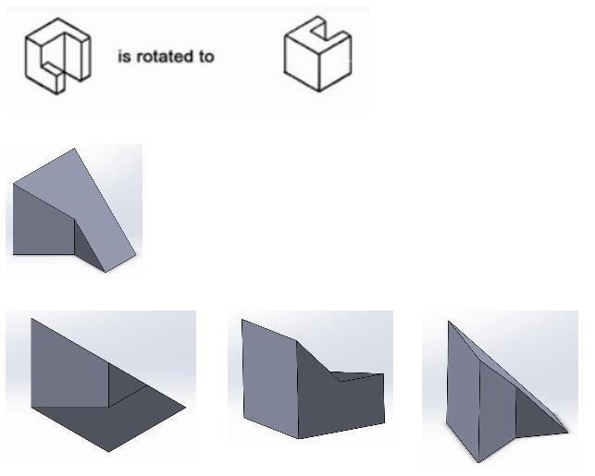

12

.

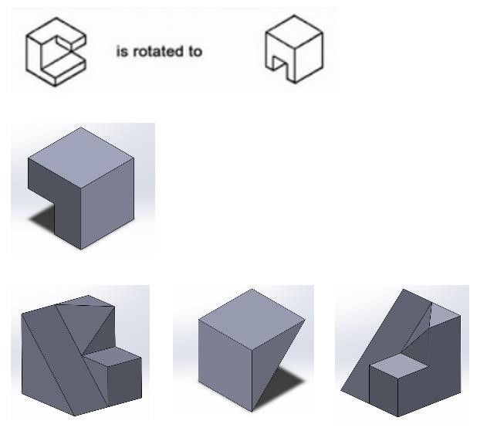

13

.

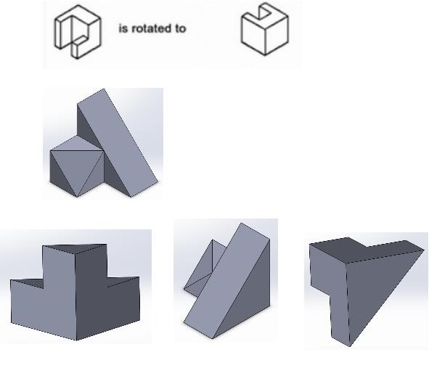

14

.

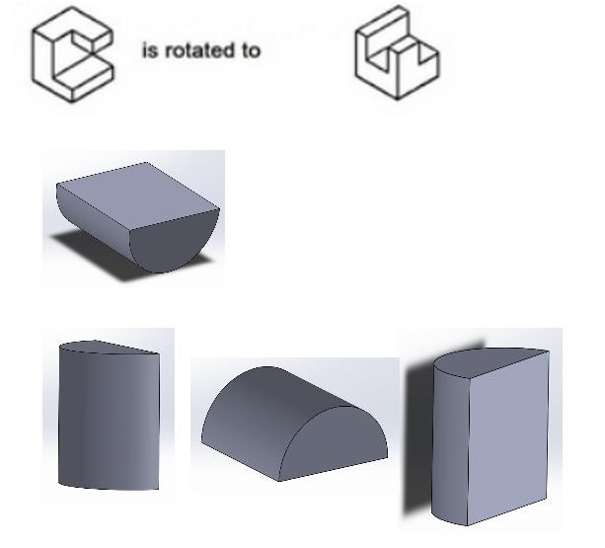

15

.