Name: _______________________________________
NUMBER AND PATTERNS WORKSHEET
Like the barcodes that identify the items you buy almost anywhere—grocery stores, bookstores, department stores—these spectra can be “read.” Before you learn how to read spectra, get your pattern identification skills in shape by matching each barcode in the left column with the identical barcode on the right. Draw a line between matching barcodes.

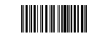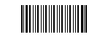
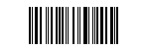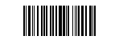

Numbers and Patterns

1) What is the next number in this sequence?_______
1, 1, 2, 3, 5,

2) What is the next, bottom, row in this triangle? _________________________
1
1 1
1 2 1
1 3 3 1
1 4 6 4 1
1 5 10 10 5 1

3) What is the next number in this sequence?_______

14, 91, 62, 53, 64,

4) Which letter comes next in the following sequence? __________
S, N, E, P, O, H, C

