Patterns In Nature

a. 

b. 

c. 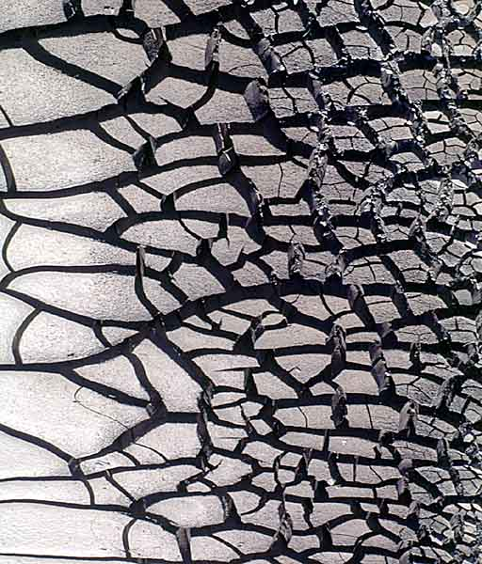

d. 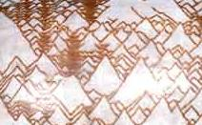

Answer Key and Sources
Part I: Patterns in Nature

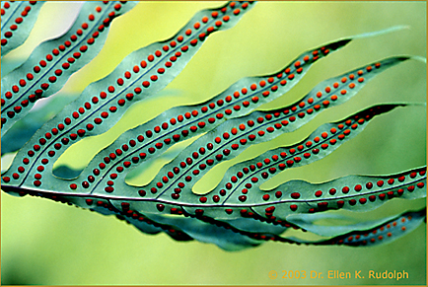
Leaf with “spores?”
http://www.drellenrudolph.com/patterns%20A/patternsA.html
Summary of a talk presented at the 13th International Congress of the International Union for the Study of Social Insects, Adelaide, Australia, January 1999.

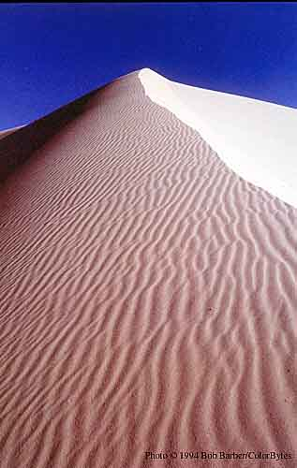
Sand Dunes
http://www.drellenrudolph.com/patterns%20A/patternsA.html
Summary of a talk presented at the 13th International Congress of the International Union for the Study of Social Insects, Adelaide, Australia, January 1999.

Mud cracks
http://www.drellenrudolph.com/patterns%20A/patternsA.html
Summary of a talk presented at the 13th International Congress of the International Union for the Study of Social Insects, Adelaide, Australia, January 1999.
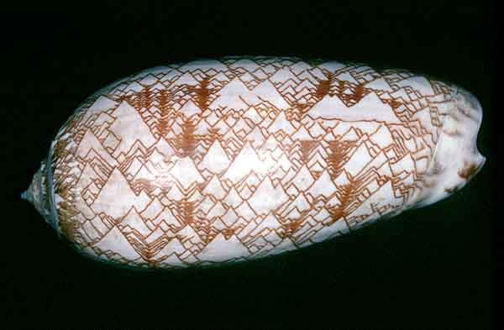
Olive Shell
http://www.drellenrudolph.com/patterns%20A/patternsA.html
Summary of a talk presented at the 13th International Congress of the International Union for the Study of Social Insects, Adelaide, Australia, January 1999.

