Graphing the Rainbow Worksheet
When light from any source—a light bulb, a computer monitor, a planet—passes through a prism or a diffraction grating, it produces a unique rainbow pattern.



The pattern may be mostly bright with a few dark stripes, or dark with a few bright stripes, or some combination.
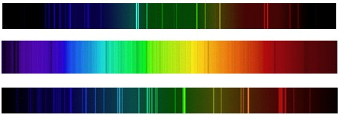

The intensity of each color of light can be plotted on a line graph, like the one below.
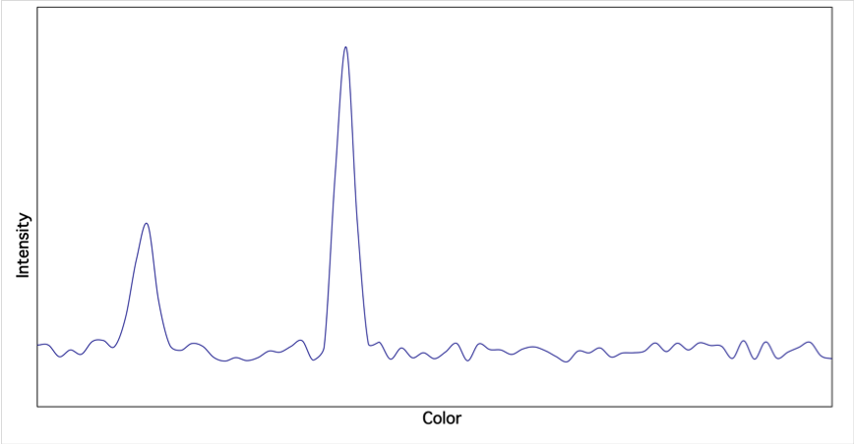

Look at the following examples. Each of the spectra on the left can also be displayed as a line plot, as shown on the right. Bright colors have high intensity, as shown along the y-axis.
The first spectrum is called a continuous spectrum. In a continuous spectrum, every color has the same intensity.

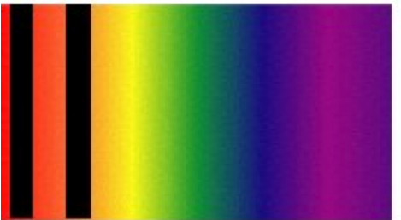
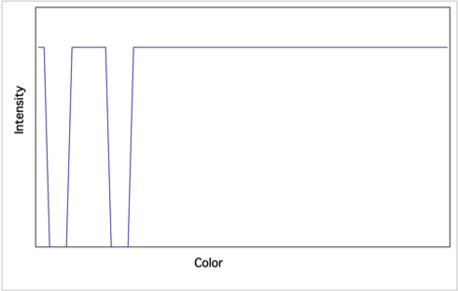
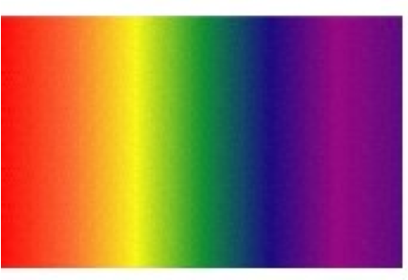

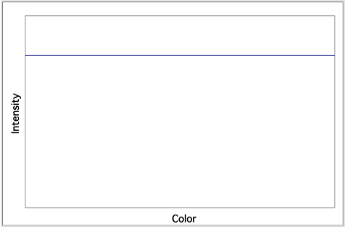
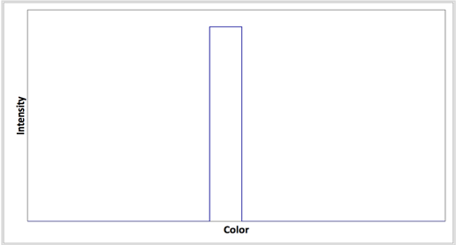

Draw arrows to match each of the spectra in column A with its corresponding line plot in column B.

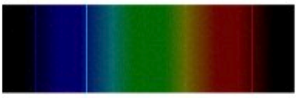
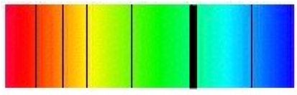
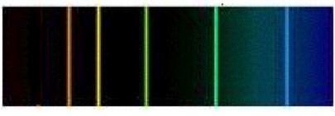
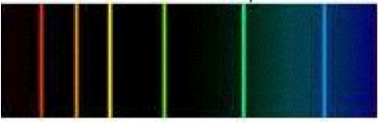
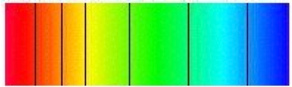
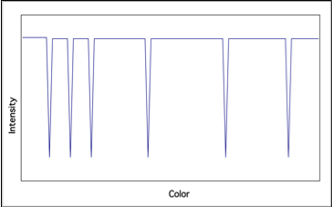
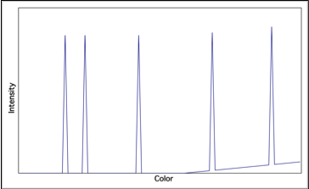
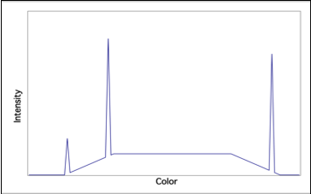
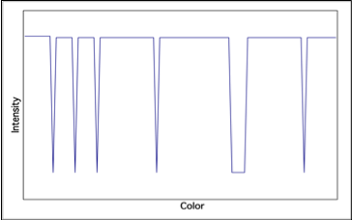
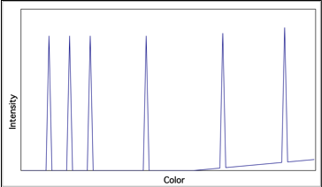
A B

