Using Spectral Data Worksheet

Instructions: Look at the data on page 1 and 2. Page 1 shows the spectra of Titan and Saturn’s rings. Page 2 shows known spectra of specific elements. Compare both pages and determine what elements are present in Titan’s atmosphere and in Saturn’s rings. Then answer the questions on page 3.

a) Titan, October 26, 2004
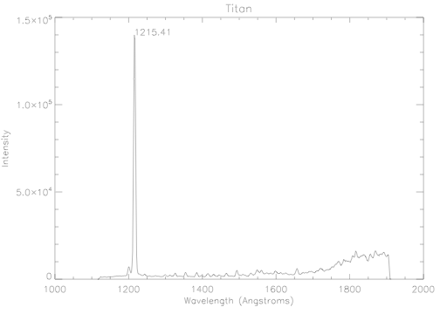
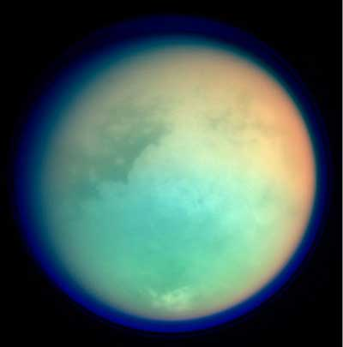

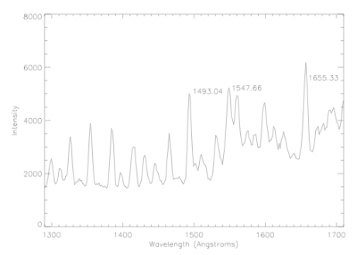

- Saturn’s rings, June 30, 2004
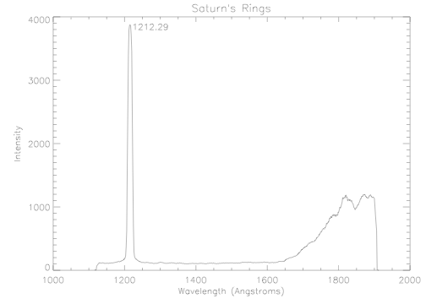


Known Spectra with wavelength in Angstroms on the x-axis and intensity on the y-axis.

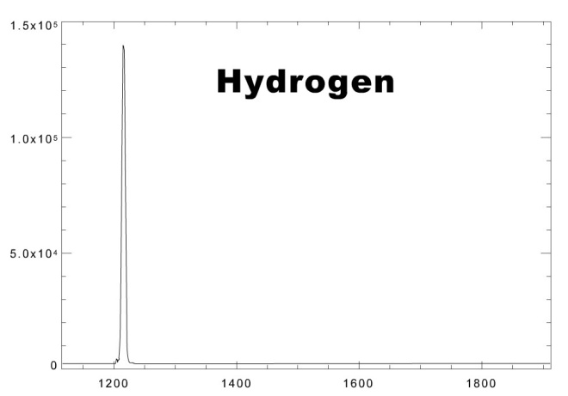
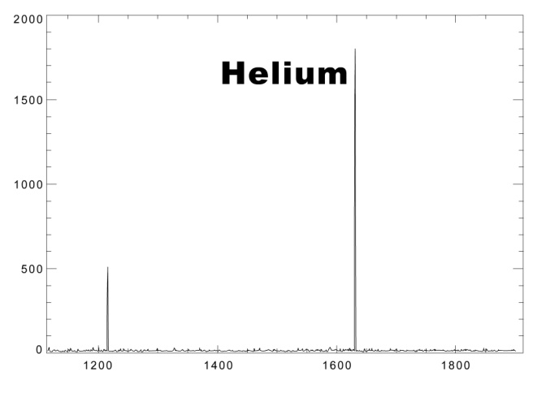
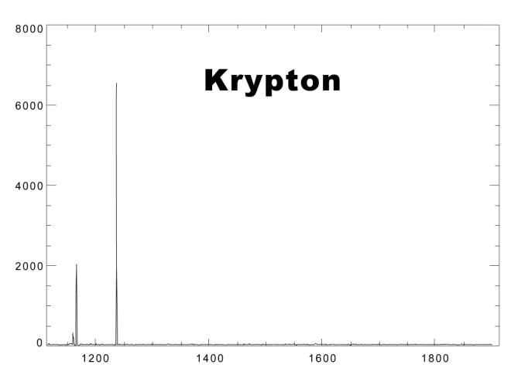
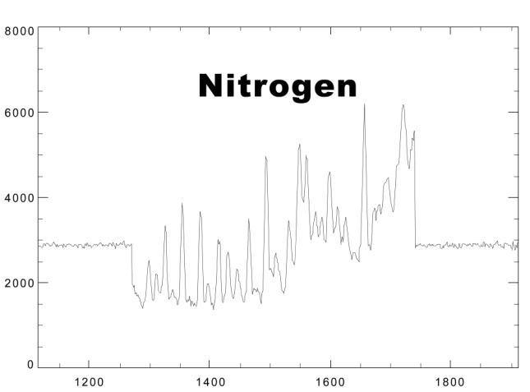
Questions
- Elements present in spectrum (a), Titan, are:

___________________________________

___________________________________

___________________________________

- Elements present in spectrum (b), Saturn’s rings, are:

___________________________________

___________________________________

___________________________________
- Why is hydrogen so abundant in these spectra?
(Hint: What do you know about the structure of hydrogen
and about its abundance in the universe?)

- Why do you think nitrogen is present in the spectra from Titan but not in the spectra of Saturn’s rings?

- Using information in the table below, compare and contrast the composition of Titan’s atmosphere and Earth’s atmosphere.
What are some reasons these differences might exist?

Titan Earth
Nitrogen 95% Nitrogen 78%
Methane 3% Oxygen 21%
Argon 2% Argon 1%

