Engineering Your Own Spectrograph
Instructions & Worksheet
Part 1: Creating an Open Spectrograph
Materials List
Each group needs:
- 1 rectangular piece of foam core board
- 2 Styrofoam cups
- 1 holographic diffraction grating (1,000 lines per mm or 25,400 grooves per inch)
- 1 ruler
- 1 meter stick
- 1 protractor
- 1 X-ACTO knife
- 1 black fine point permanent marker
- 1 incandescent flashlight with focusing beam (mini mag-lights are best; LED flashlights do not work.)
To share with the entire class:
- 1 role masking tape
- Red, green and violet markers
- Sheets of paper for calculations and sketches
Making the Background Screen
- Find the center of the longer side of the foam core board. Draw a line down the center as shown below.
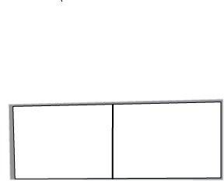
Line drawn down center of foam core board

- Push a table or desk against a wall. Tape the foam core board above the table, leaving a small gap between the bottom of the board and the table. This is your background screen.

Making the Grating Stand
- Cut a 5 cm long slit in the bottom of the Styrofoam cup as shown below.
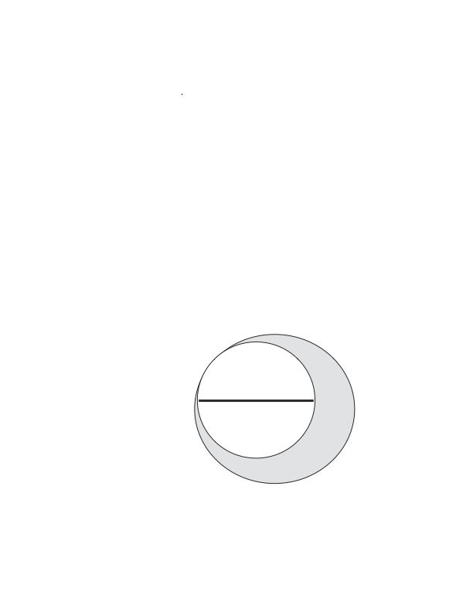
Cut a slit in the bottom of the cup

- Using a straight edge, draw a line on the cup that is perpendicular to the slit, as shown below.
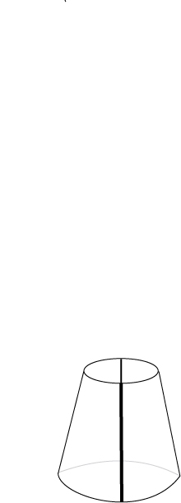
Draw a line perpendicular to the slit on the cup

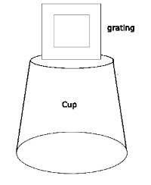
- Place your diffraction grating into the slit on the bottom of the cup to complete your grating stand, as shown below.
Grating
Cup

Making the flashlight stand
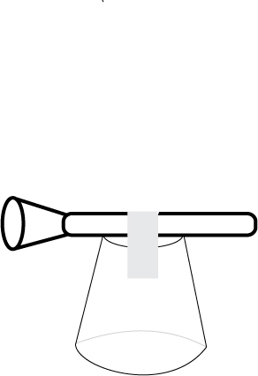
- Loosely tape the flashlight to the bottom of a Styrofoam cup using masking tape, as shown below.
Flashlight
Tape

Finding the Angles
- Place the grating stand in front of the screen so that the center of the grating lines up with the central line on the screen.
- Place the meter stick on the table perpendicular to the screen. Align the zero centimeter line with the front of the screen and the edge of the meter stick against the Styrofoam cup. Using masking tape, tape the meter stick to the table top at each end so that it does not shift.
- Turn on and then focus the flashlight so it makes a small, bright beam on the screen.
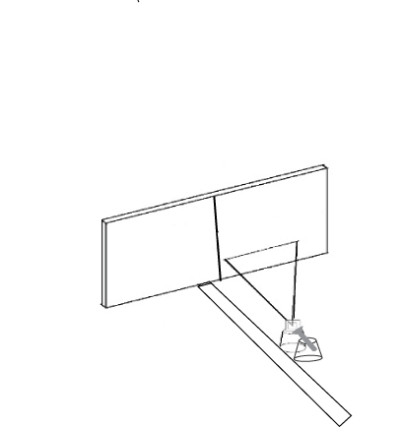
Screen
Meter stick
Grating stand

Flashlight stand

- Place the flashlight stand directly behind the grating stand facing the screen. Rest the head of the flashlight on the grating stand so the beam of light travels directly through the center of the grating.
- Slide the two stands backward and forward along the meter stick until your spectra are clear and bright. As long as the spectra are on the screen, you can place the stands anywhere along the meter stick. Do not shift the stands between measurements.
- Choose either the spectrum on the right OR left to make your measurements.
- Measure the distance from the grating and the screen by reading the meter stick where it lines up with the black line on the cup. Record this distance: ___________________
- Measure the distances from the centerline on the screen to the very edge of the red and violet light. Record these distances: red _____________ violet _________________
- Choose a point in the green area of the light, and measure and record the distance. ________
- Using the measurements recorded, on a sheet of paper draw a right triangle using the distance from the grating to the screen, and each of the distances to the colors measured. Mark the location of each of the colors with an X, and connect the apex of the triangle with each X as shown in the drawing below.

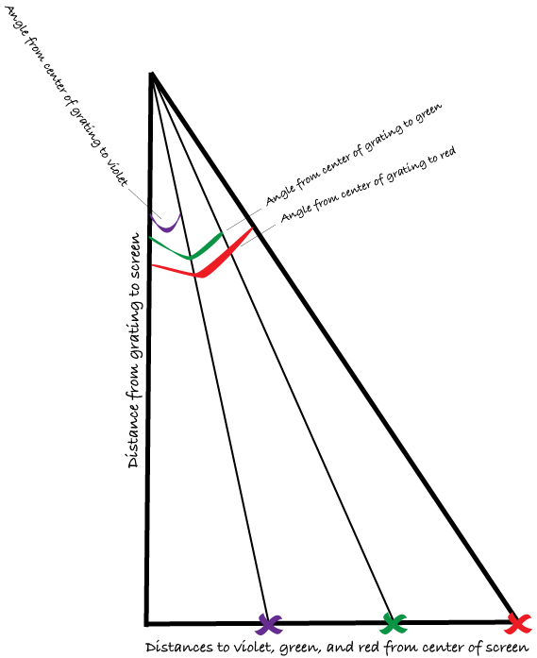

- Using a protractor, measure and record the angles to each color.
Red _____________ violet _______________ green ________________
- Using the Pythagorean Theorem and a calculator, determine the hypotenuse lengths for the triangles.
Hypotenuse Lengths for: | Violet Triangle | Red Triangle | Green Triangle
Calculated
Measured
- Measure them with a ruler to confirm the lengths.
- Do your numbers match? Why or why not?

Part 2: Designing and Building an Spectrograph Enclosure
Now that you have found the angles to the colors in the spectrum, and the distance to those colors, design an enclosed spectrograph with your team. As a group, explore the following questions before you start. Create a drawing of your design idea.
Shape and Size
- What shape will make your spectrum lie on a flat surface?
- What is the simplest design to build and look through?
- How big does a spectrograph need to be to work? (Tip: Think about the hypotenuse you calculated.)
- Is there a limit to how big it could be?
- Do you want a smaller spectrograph that is easy to take with you?
- What is the best size to use for it to be useful and portable?
Placement and Design of Parts
- Where will you place your diffraction grating?
- How will the light come through, and how much light is needed?
- Where will the light come through, and where will you see the spectrum?
- Where will your spectrum be when you look into the spectrograph?
- Is there anything you can do to make your spectrum easier to see?
Designing Your Mission
Create an imaginary mission your spectrograph might undertake. Consider the following questions as a group:
- Is your mission ground- or space-based?
- If your mission is space-based, will it orbit the Earth or travel to another planet?
- What are your mission goals?
- What limitations does your spectrograph have?
- What will the spacecraft look like?
- Are there size or weight restrictions to consider?
- How much will the mission cost?
Presenting Your Findings
Present your design and mission to the rest of the class.
Ask the class for feedback; be open to suggestions.

