**Truss Configurations Sign-Up Sheet**

**Truss A**

___________________________________

___________________________________

___________________________________

**Truss B**

___________________________________

___________________________________

___________________________________

**Truss C**

___________________________________

___________________________________

___________________________________

**Truss D**

___________________________________

___________________________________

___________________________________

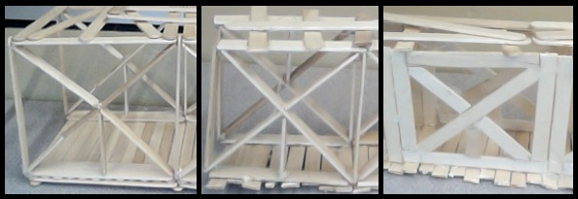Example joint style configurations: (left to right) butt joints, notched joints and overlapping joints.

**Truss Configurations Sign-Up Sheet**

**Truss E**

___________________________________

___________________________________

___________________________________

**Truss F**

___________________________________

___________________________________

___________________________________

**Truss G**

___________________________________

___________________________________

___________________________________

**Truss H**

___________________________________

___________________________________

___________________________________

****Example joint style configurations: (left to right) butt joints, notched joints and overlapping joints.