Viking Ship Anatomy Worksheet
- Use the following vocabulary words to label the components of the Viking ship below.
Rudder, sail, hull, mast, drag, stem, oars, keep, bow
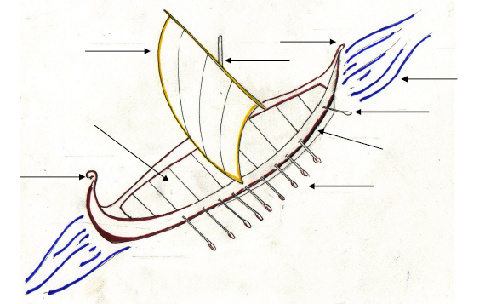

- Now, consider how the ship would sail if you removed its components, one at a time. For example:
Without the SAIL The ship could not use the energy of the wind to propel itself.
Without the RUDDER ________________________________________________________
Without the _________ ________________________________________________________
Without the _________ ________________________________________________________
Without the _________ ________________________________________________________

