Viking Ship Anatomy Worksheet Answers
- Use the following vocabulary words to label the components of the Viking ship below.
Rudder, sail, hull, mast, drag, stem, oars, keep, bow
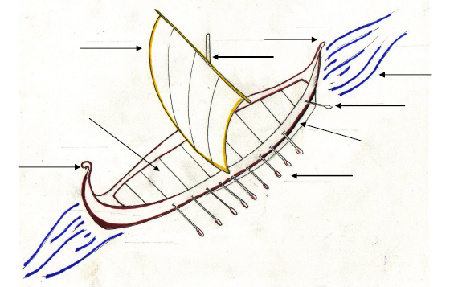
sail
stem
mast
drag
rudder
hull
keel
bow
oars

- Now, consider how the ship would sail if you removed its components, one at a time. For example:
Without the SAIL The ship could not use the energy of the wind to propel itself.
The ship could not sail across the water.
Without the RUDDER ________________________________________________________
There would be no support for the sail.
mast
Without the _________ ________________________________________________________
drag
The motion of the ship wouldn’t be slowed by friction.
Without the _________ ________________________________________________________
keel
There would be less ballast to stabilize the ship.
Without the _________ ________________________________________________________

