Dress for Success Activity –
Materials Analysis Worksheet
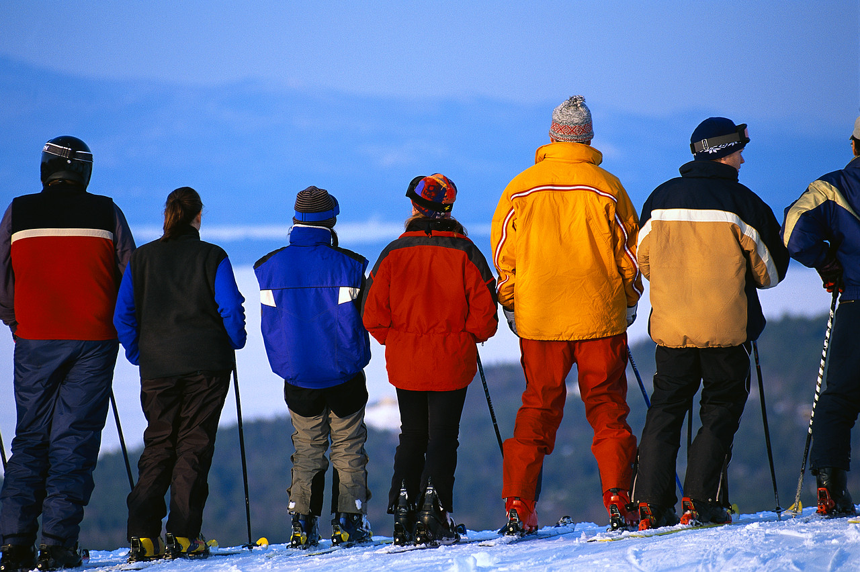
Instructions
Complete the following questions.
- Define your problem in a complete sentence. What type of climate are you designing your new material for?

- Outline a process that you will use for testing different materials for resistance to wind, snow and cold temperatures. How will you test how well the material works in:
Wind:

Snow:

Cold Temperatures:

- Choose five materials to analyze for your final design. Test each one of these materials for durability, resistance to wind, resistance to water and resistance to temperature. Rank each material from 1 to 5 (with 1 as the best overall performance).
Material  Name | Description | Durability | Resistance to Wind | Resistance to Water/ Snow | Resistance to Temperature | Rank
1.
2.
3.
4.
5.

- From your analysis in #3, decide which materials to use for your design. List the materials you will be using here and why you chose each material to use. What makes these materials good for blizzard weather conditions?

- Draw your design in the space below. Label your drawing. How will you layer your materials for effectiveness? Why?
- How well do you think your new material will work in resisting water, wind and temperature? Why?

- Give your new material a name. Test your new material.
Material  Name | Description | Durability | Resistance to Wind | Resistance to Water/Snow | Resistance to Temperature

- How well does your new material work? Are there any things you would change to improve your new material?

- How well did your process work for testing your material?

- How would this new material be used in during a blizzard?

- How would you market your new material to people who live in an area that experiences blizzards?

