Forecasting with Clouds
When you see clouds, observe their shape, color and placement in the sky to learn what weather to expect. Different clouds help meteorologists tell what kind of weather is around them. Learn the following different types of clouds to help predict the weather.

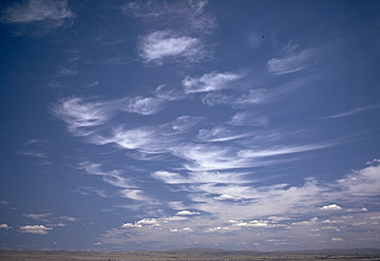
Cirrus clouds are thin and wispy. They point in the direction in which the wind blows. Cirrus clouds do not contain much moisture and are a sign of fair weather.

Image source: U.S. Centennial of Flight Commission, http://www.centennialofflight.gov

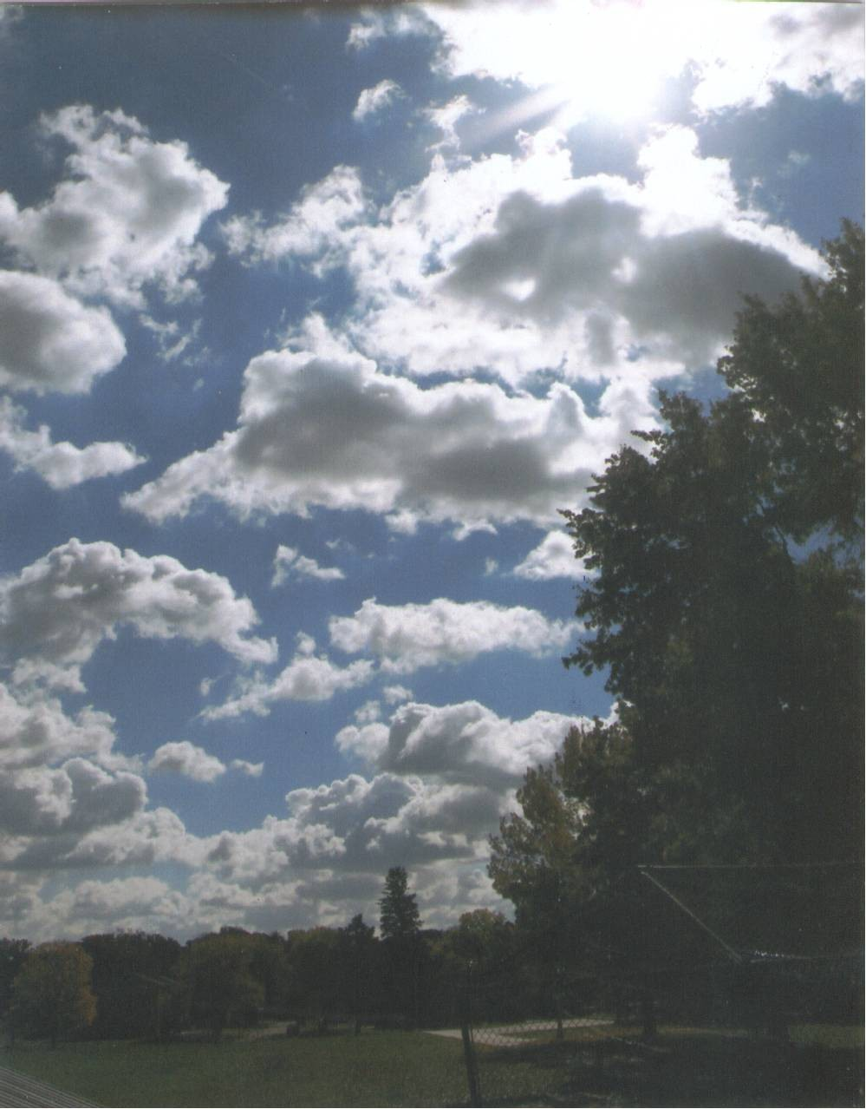
Cumulus clouds look like giant cotton balls in the sky and have very large spaces of sky between them. Usually, cumulus clouds carry no rain, but during the spring and summer they can change into cumulonimbus clouds.

Image source: International Global Atmospheric Chemistry, NOAA, http://www.igac.noaa.gov

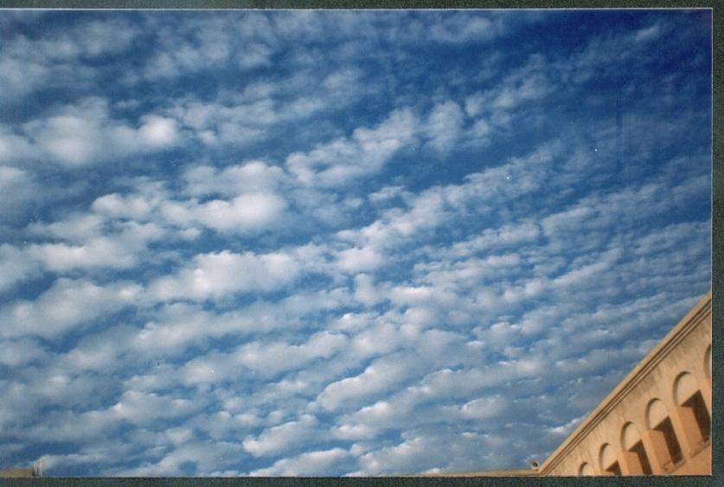
Altocumulus clouds look like fuzzy bubbles in long rows and strings. These clouds signify that a cold front is coming. In the summer, when it is warm and sometimes humid, altocumulus clouds may turn into thunderstorms when a cold front approaches.

Image source: NASA, http://www.larc.nasa.gov

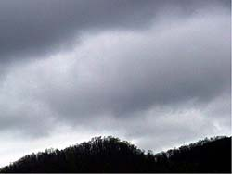
Nimbostratus clouds are often called rain clouds. They generally have a uniform dark gray appearance and hang low, covering most of the sky. Their bottoms are typically blurred and indistinct due to falling rain or snow. Nimbostratus clouds bring light to moderate precipitation.

Image source: NASA, http://www.larc.nasa.gov

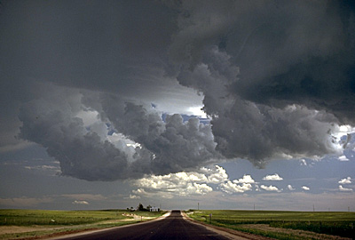
Cumulonimbus clouds are thunderstorm clouds. They are tall and wide and carry heavy rain, thunder and lighting. When you see cumulonimbus clouds, you know that rain is coming very soon.

Image source: U.S. Centennial of Flight Commission, http://www.centennialofflight.gov

