Backyard Weather Station Activity –
Tool #2: Barometer Worksheet

Materials
Each group should have:
- One clean 2-liter plastic soda bottle | - Any color liquid food coloring
- One clear plastic cup | - ½ liter of water
- Marker

Instructions
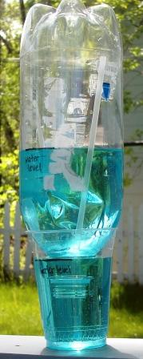
- Pour a couple of inches of water into a plastic cup. Add a few drops of food coloring to the water.
- Place the 2-liter bottle upside down inside the cup. Check to make sure it fits snugly but is not airtight (i.e., the mouth of the bottle must be below the waterline but not touching the bottom of the plastic cup).
- Insert a straw between the 2-liter bottle and the cup to allow air to come into the cup. Make sure the straw is above the water line in the cup.
- Use a marker to note the water level on the side of the plastic cup and the water level on the side of the 2-liter bottle

Using the Barometer
- Keep track of the water level inside the plastic cup.
- The general rule of thumb is as follows: clear weather results in higher air pressure, which tends to push down the water in the plastic cup, causing the water level to fall in the plastic cup and rise in the 2-liter bottle (see figure, left).
- 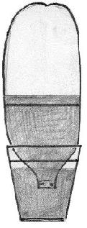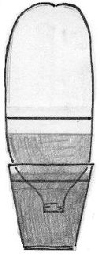In the case of an approaching storm, the air pressure drops, causing the water level in the plastic cup to rise and the water level in the 2-liter bottle to fall (see figure, right).
Clear weather /
high pressure
Stormy weather /
low pressure
- Use your barometer to observe changes in air pressure over a period of time.
- Record air pressure data in the table below.

Data Collection
Use the following table to collect data from your observations.
Time of Observation | Water Level in  2-liter bottle | Water Level in Plastic Cup | Weather Observations (e.g., clear, cloudy, etc)

Graphing

Use the data from the table to create a histogram plot of the water level in the 2-liter bottle.

Water Level in 2-liter Bottle
Observations

Analysis

- What happens to the water level in the cup when the water level in the 2-liter bottle increases? What about when the water level in the 2-liter bottle decreases? Why?

- Are there any patterns relating the weather observations to the level of water in the bottle? What are they?

- Are there any outliers in the data? If so, why?

