Backyard Weather Station Activity –
Tool #4: Rain Gauge Worksheet
Materials
Each group should have:
- Wide glass (to catch the rain) | - Masking tape
- ruler | - water
      - Straight-sided, thin jar (a graduated cylinder works best) (to measure the amount of rain)
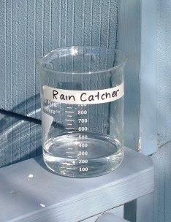
Instructions
- Using a ruler, pour one inch of water into the wider glass jar.
This jar is the rain catcher.
- Pour this water into the straight-sided, thin jar.
This jar is the rain gauge.
- Use masking tape to mark the water level on the rain gauge.
Using the Rain Gauge
- Set the rain catcher in an area outside that has no obstructions to block the rain (such as overhanging branches or roofs).
- After it rains, pour the water from the rain catcher into the rain gauge and use the one-inch water line taped to the gauge to determine the amount of rainfall, in inches.
Data Collection
Use the following table to collect data from your observations.
Time of Observation | Rainfall (in inches) | Notes

