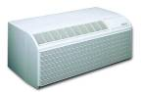

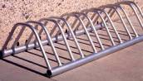    



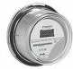  

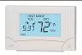

cfl-bulbcfl-bulbcfl-bulbcfl-bulbcfl-bulbcfl-bulbcfl-bulbcfl-bulbcfl-bulbcfl-bulbcfl-bulbcfl-bulbcfl-bulbcfl-bulbcfl-bulbcfl-bulbcfl-bulbcfl-bulbcfl-bulbcfl-bulbcfl-bulbcfl-bulbcfl-bulbcfl-bulbcfl-bulbcfl-bulbcfl-bulbcfl-bulbcfl-bulbcfl-bulbcfl-bulbcfl-bulbcfl-bulbcfl-bulbcfl-bulbcfl-bulbcfl-bulbcfl-bulbcfl-bulbcfl-bulbcfl-bulbcfl-bulbcfl-bulbcfl-bulbcfl-bulbcfl-bulbcfl-bulbcfl-bulbcfl-bulbcfl-bulbcfl-bulbcfl-bulbcfl-bulbcfl-bulbcfl-bulbcfl-bulbcfl-bulbcfl-bulbcfl-bulbcfl-bulbcfl-bulbcfl-bulbcfl-bulbcfl-bulbcfl-bulbcfl-bulbcfl-bulbcfl-bulbcfl-bulbcfl-bulbcfl-bulbcfl-bulb

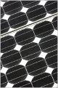

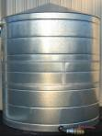



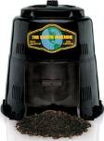

big-wind_turbinebig-wind_turbinebig-wind_turbinebig-wind_turbinebig-wind_turbinebig-wind_turbinebig-wind_turbinebig-wind_turbinebig-wind_turbinebig-wind_turbinebig-wind_turbinebig-wind_turbinebig-wind_turbine

big-wind_turbinebig-wind_turbinebig-wind_turbinebig-wind_turbinebig-wind_turbinebig-wind_turbinebig-wind_turbinebig-wind_turbinebig-wind_turbinebig-wind_turbinebig-wind_turbinebig-wind_turbinebig-wind_turbine

