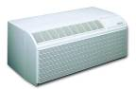 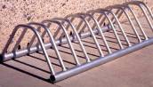  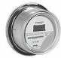 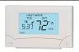

cfl-bulbcfl-bulbcfl-bulb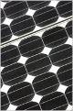   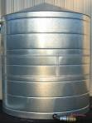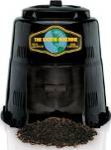big-wind_turbine

    Programmable_Thermo_4

cfl-bulbcfl-bulbcfl-bulb   big-wind_turbine

    Programmable_Thermo_4

cfl-bulbcfl-bulbcfl-bulb   big-wind_turbine