Electricity and Magnetism Pre/Post Test Answers

Please circle the best answer.
- True or False: Electricity is a form of energy.
  - True
  - False

- How is electricity formed?
  - Transfer of protons
  - Transfer of atoms
  - Transfer of electrons
  - Transfer of neutrons

- What are the two types of electricity?
  - Fast and slow electricity
  - Static and current electricity
  - Hot and cold electricity
  - Proton and electron electricity

- True or False: A magnet has four poles: a north, south, east and west pole.
  - True
  - False

- Engineer’s use magnets and magnetism to produce a lot of different things.
Which of the following is NOT produced using magnets?
  - Memory storage
  - Images of the human body
  - Building a house
  - Sort recyclable materials

- True or False: An electrical circuit is any path electrons can move through.
  - True
  - False

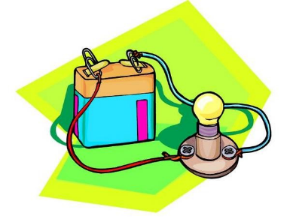
- Electrical current can easily travel through materials like metals.
What are these types of materials called?
  - Insulators
  - Resistors
  - Batteries
  - Conductors

- True or False: You cannot make a battery out of fruit.
  - True
  - False

