Cars and Air Quality Connections Worksheet (K-2)
Do gas-powered and electric cars affect our air?

Together, we are going to find out:
- Do cars change how clean the air is?
- Does dirty air affect our health?
- Can certain cars help make the air cleaner?

1. Watch the video of vehicles in traffic. Draw or write about what you saw:
Class Reflection: Do you think cars affect how clean the air is? Share your thoughts as a class.

2. Let’s find out about one type of air pollution that comes from vehicles.
Particulate Matter (PM)
Particulate Matter, also called PM, is a type of air pollution. Let’s learn more about air pollution in this video (watch up to 2:24).
Particulate Matter is a pollutant made up of very tiny particles and droplets that float in the air.
- PM comes from natural sources like dirt, dust, and wildfire smoke.
- PM comes from human-made sources like soot from burning fuels for energy and heat.
- PM can make the air hazy.
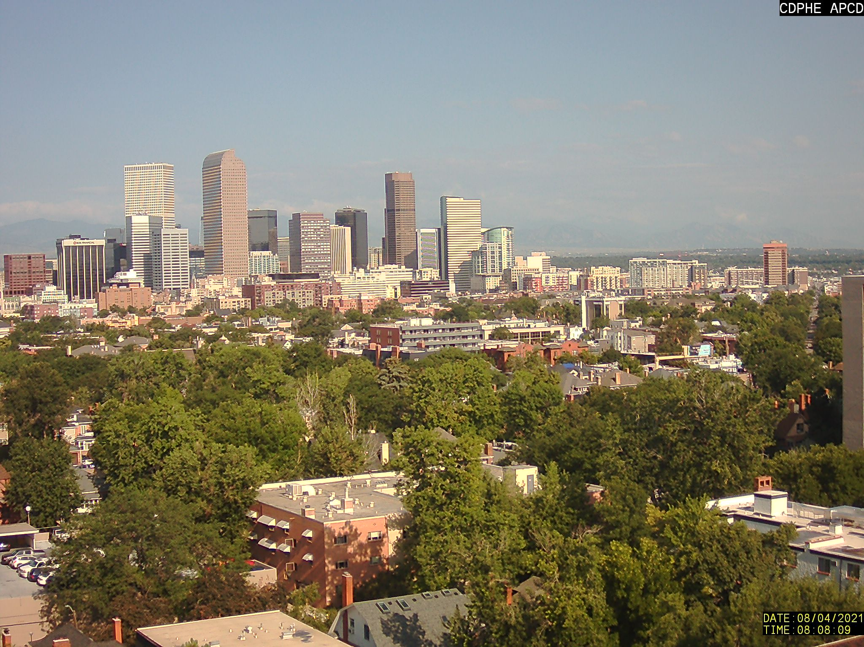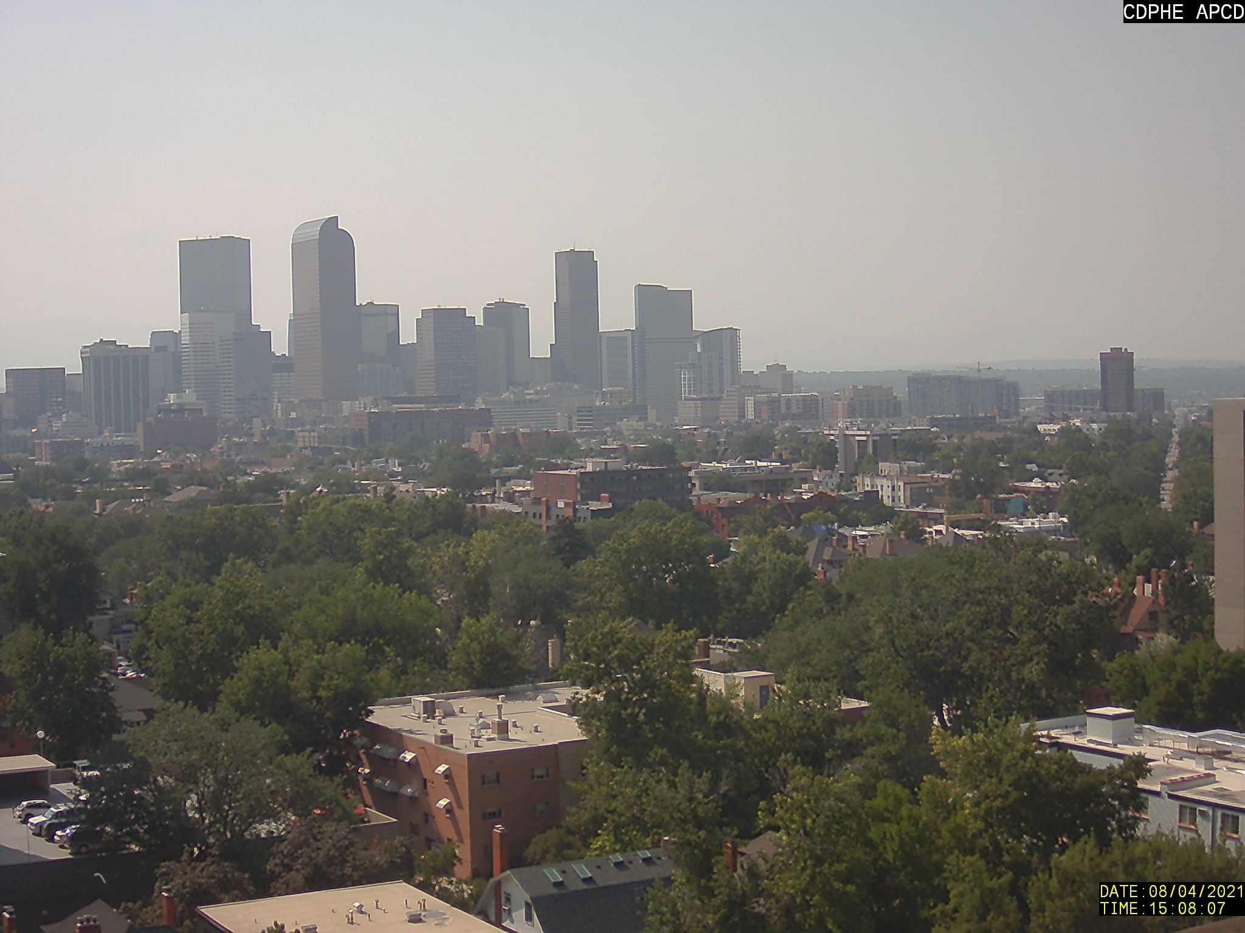
Look at two photos that were taken on the same day at different times.

What looks the same? What looks different? Describe what you observe.
- Write a plus sign “+” on the photo that has more PM.
- Tell why you think this photo has more PM.
- Write a minus sign “−” on the photo that has less PM.
- Tell why you think this photo has less PM.
- Draw a “” on the photo that has dirtier air.
- Tell why you think this photo has dirtier air.
      - Draw a “” on the photo that has cleaner air.
- Tell why you think this photo has cleaner air.

3. How does air pollution affect our health?
Draw a line to match the words and pictures to explain how breathing PM affects our health:
Words:  - Irritates the eyes, nose, and throat  - Gets into the lungs and bloodstream  - Triggers asthma and allergies | Pictures:  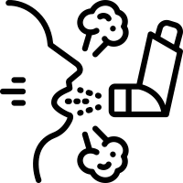  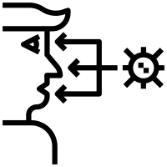  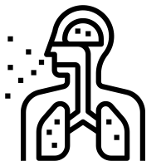

4. Let’s figure out how gas-powered cars and electric cars work.
Now, let’s put together what we now know about PM air pollution and its health effects to learn how different types of vehicles affect how clean the air is.
- First, watch the video about how a gas-powered car works.
- Now, watch the video about how an electric vehicle, also called an EV, works.
How are electric cars and gas-powered cars the same? Draw or write your answer:

How are electric cars and gas-powered cars different? Draw or write your answer:

Class Reflection: Share your thoughts on the following questions as a class:
- Is clean air important?
- Do gas-powered or electric cars make our air dirtier?
- Do gas-powered or electric cars make our air cleaner?

