Internal Combustion Engine, EV & Air Quality Worksheet Answer Key
How do internal combustion engines and electric vehicles (EV) affect our air?

Together, we are going to find out:
- Does vehicle transportation affect air quality?
- What type of air pollution comes from vehicles?
- How does air pollution affect our health?
- Can certain vehicles help make the air cleaner (healthy)?

1. Watch the video about vehicles and air pollution. Write or draw what you observe:
Answers vary.
Class Reflection: How do vehicles affect how healthy the air is? What solutions do you think could help reduce air pollution from vehicles? Share your thoughts as a class. Answers vary.
2. Particulate Matter (PM)
Particulate Matter (PM) is a pollutant made up of very tiny particles and droplets that float in the air.
- PM comes from natural sources like dirt, dust, and wildfire smoke.
- PM comes from human-made sources like soot from burning fuels for energy and heat.
- PM can make the air hazy.
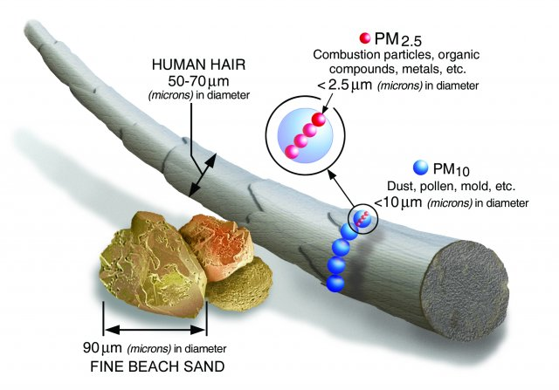
Look at the image of the size of two types of particulate matter, PM 2.5 and PM 10, compared to other objects.
- How does the size of PM 2.5 compare to PM 10?
PM 2.5 is much smaller than PM 10. Both sizes of PM are very small.

- What do you notice about the size of PM 2.5 and PM 10 compared to the size of a human hair and a grain of sand?
PM 2.5 and PM 10 are much smaller than the width of a human hair and a piece of sand.

3. Ozone
Ground-level ozone is a type of air pollution that is formed from emissions released into the atmosphere from burning fossil fuels for energy. Let us learn more about ozone air pollution in this video.

Ozone: Good Up High, Bad Nearby!
- Ozone is an invisible gas, so a clear, blue sky can still have high ozone pollution.
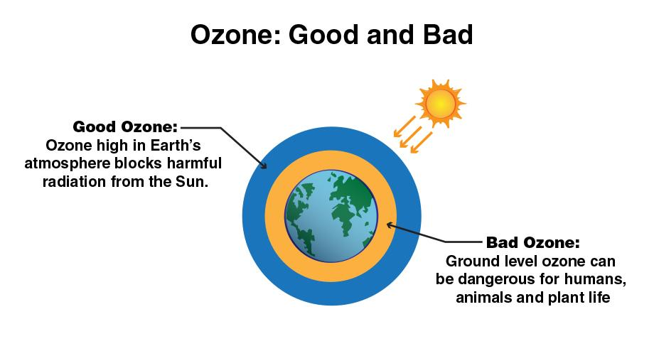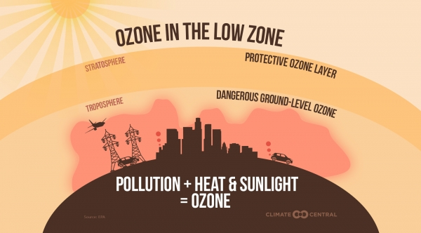
- Look at the two images. With a partner, discuss the similarities and differences of ozone in the atmosphere. Next, share observations as a class.
Similarities: Ozone is a gas. Ozone is in different parts of the atmosphere-high in the stratosphere and low in the troposphere.
Differences: Ozone up high is naturally made and gives protection from UV radiation from the sun. Ozone down low is human-made and is a toxic air pollutant.
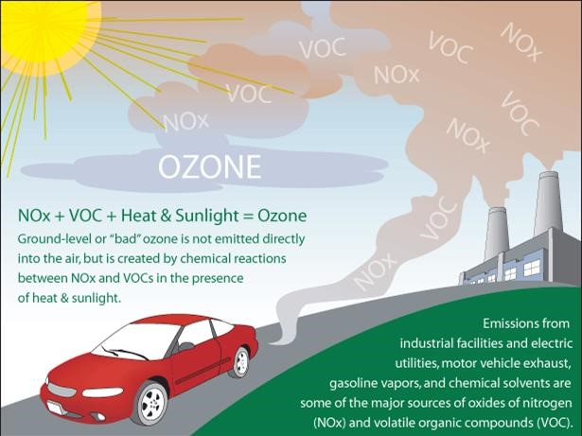
- Label the image with the correct terms to explain how ozone is made.
Word bank: emissions, warm air, sunlight, ground-level ozone
Ground-level ozone is a bad air pollutant that is created from a combination of exhaust pollution, high air temperatures, and sunlight.
4. How does PM air pollution affect our health?
Draw a line to match the words and pictures to explain how breathing PM affects our health:
Health Effects of Breathing PM:  - Premature death in people with heart or lung disease  - Non-fatal heart attacks  - Irregular heartbeat  - Aggravated asthma  - Decreased lung function  - Increased respiratory symptoms, such as irritation of the airways, coughing or difficulty breathing. | Draw an image of one health effect of breathing PM:  Answers vary.
5. How does ozone air pollution affect our health?
Draw a line to match the words and pictures to explain how breathing ozone affects our health:
Health Effects of Breathing Ozone:  - Cause coughing and sore or scratchy throat.  - Make it more difficult to breathe deeply and vigorously and cause pain when taking a deep breath.  - Inflame and damage the airways.  - Make the lungs more susceptible to infection.  - Aggravate lung diseases such as asthma, emphysema, and chronic bronchitis.  - Increase the frequency of asthma attacks. | Draw an image of one health effect of breathing ozone:
6. How internal combustion engine vehicles and EVs work
Now, let’s put together what we now know about PM air pollution and its health effects to learn how different types of vehicles affect how clean the air is.
- First, watch the video about how an internal combustion engine vehicle works.
- Now, watch the video about how an electric vehicle (EV) works.
How are EVs and internal combustion engine vehicles the same? Draw or write your answer:

EV and ICE vehicles both use a source of energy to power the vehicle. EV and ICE vehicles both range in size from personal cars and trucks to buses to semi-trucks. ICE and EV meet people’s transportation needs.

How are EVs and internal combustion engine vehicles different? Draw or write your answer:

EVs have a battery motor that must be charged to run. EVs do not release any emissions or air pollution into the atmosphere when they are on or driving. EVs have a shorter driving range than ICE. EVs can be charged using renewable energy sources but are mainly charged by plugging into the power grid.

ICE vehicles have an engine that burns gas to run. ICE vehicles release emissions and air pollution into the atmosphere when they are on and driving. ICE vehicles have a longer driving range than EV. ICE vehicles use non-renewable fossil fuels that release greenhouse gases when burned, which contribute to climate change.

Class Reflection: Share your thoughts on the following questions as a class:
- Is clean air important? Explain your reasoning.
- Do internal combustion engine or EVs make our air dirtier? Explain with evidence.
- Do internal combustion engine or EVs make our air cleaner? Explain with evidence.

