Climate Change and Cars Worksheet
Do gas-powered and electric cars affect our climate?

Together, we are going to find out:
- What is the greenhouse effect?
- What is the carbon cycle?
- How does transportation affect the greenhouse effect?

1. What is the Greenhouse Effect?
Instructions: After watching the video “What is the Greenhouse Effect?” answer following questions.

- Describe the greenhouse effect in your own words.

- Why is the greenhouse effect important to life on Earth?

- How do human activities impact the greenhouse effect?

- What else did you learn from the video?

2. Carbon Dioxide (CO₂) on Earth
Carbon dioxide, also called CO₂, is a type of gas naturally found on Earth. Take a few minutes to look over the Carbon Cycle image below. What do you notice?

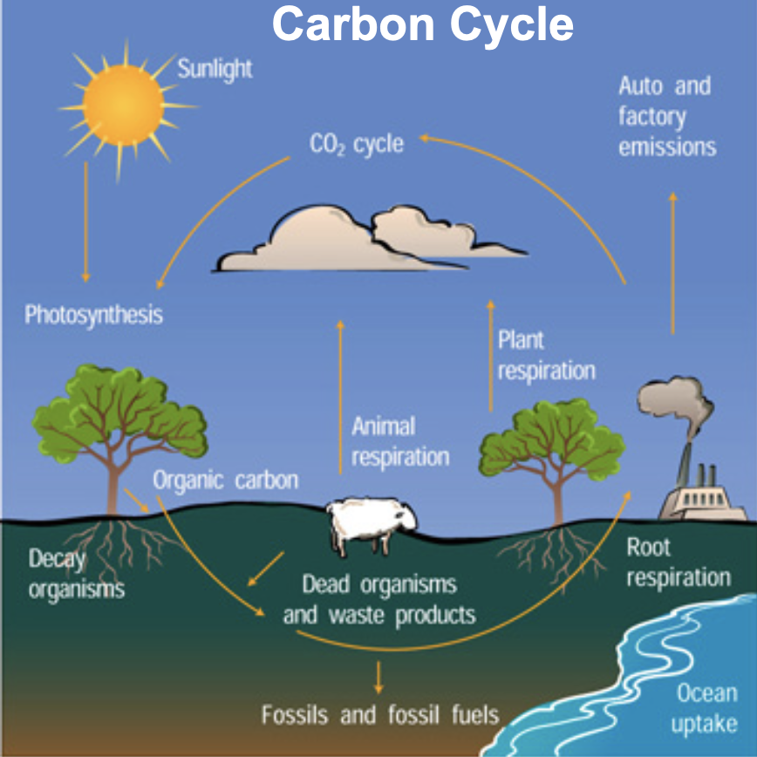

After watching “What is the Carbon Cycle?” video, answer the following questions.
- Where is CO₂ released into the atmosphere?

- How does CO₂ move from the atmosphere through Earth?

Let’s review!
- CO₂ comes from natural sources…(respiration of animals and humans, decay of dead plants & animals, etc.)
- CO₂ also comes from human sources…(burning of fossil fuels for energy in cars, power plants, etc.)
- CO₂ moves through Earth’s atmosphere (air), hydrosphere (water), biosphere (living things), and geosphere (land).

3. How are humans increasing CO₂ levels in the atmosphere?
Look over the graph below showing the amount of CO₂ in the atmosphere.

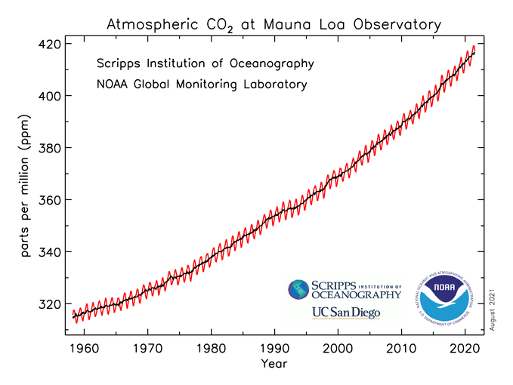

- What patterns do you notice in the graph?

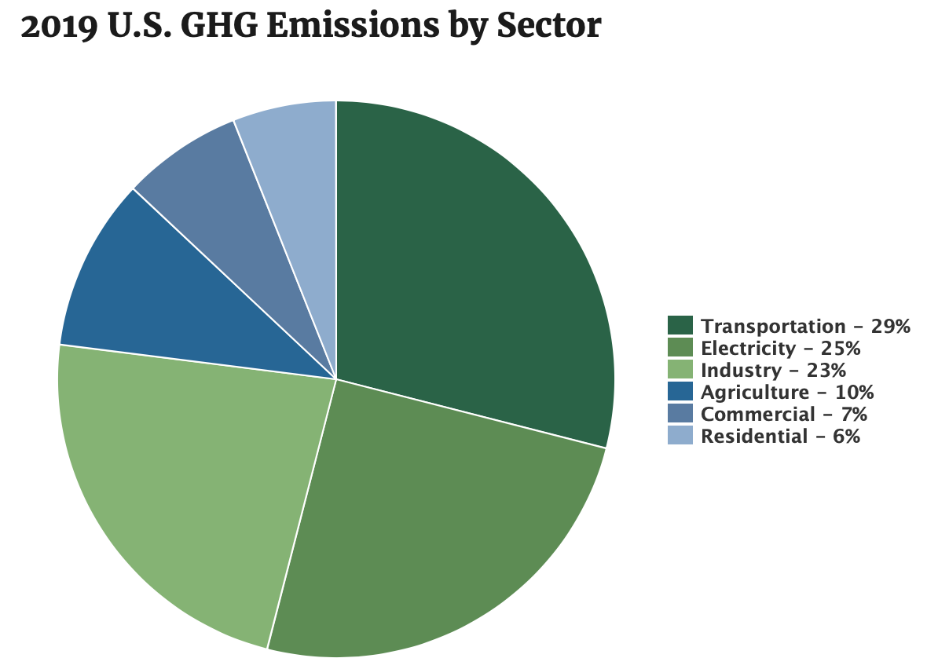
- Look at the image above. What category of human activities contributes the most to the extra CO₂ in the atmosphere?

4. Carbon emissions (exhaust) from cars.
After watching the video “What if Carbon Left Your Tailpipe as Solid Chunks?” think-pair-share the following questions as a class:

- What do they show coming out of the car’s tailpipe in the video?

- How many car “turds” does an average car dump per year? Per mile? How is that shown in the video?

Class Reflection: Share your thoughts on the following questions as a class:
- How do you get to school? Do you take the bus? Do your parents drop you in their car? Do you walk? Do you carpool with a friend?
- Which form of transportation do you think is cleaner?
- Which form of transportation do you think is less clean?
- Are there cars out there that do not have exhaust or (or “turds” like the car in the video)?

