Energy & Nutrient Flow Concept Quiz

- Which of the following is an example of an environment?
  - Evaporation
  - Tropical rain forest
  - Buoyancy
  - Ecology
- A biodome is:
  - A rock group
  - A space station
TeachEngineering.org – Free STEM Curriculum for K-12
  - A self-contained environment
  - A wildlife refuge
- Label the following as producers or consumers in the food chain.


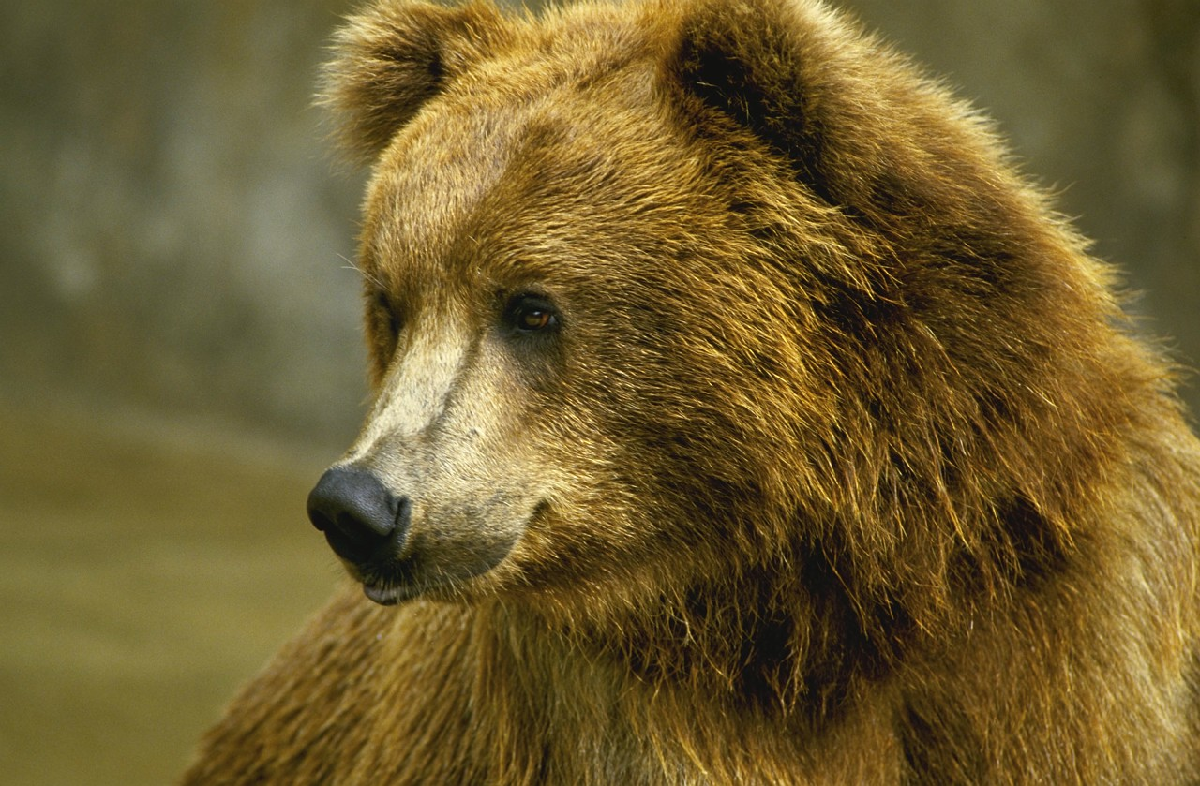

______________ ______________ ______________ _____________ ______________
- In the boxes below, fill in the three main stages of the water cycle: evaporation, precipitation, condensation.
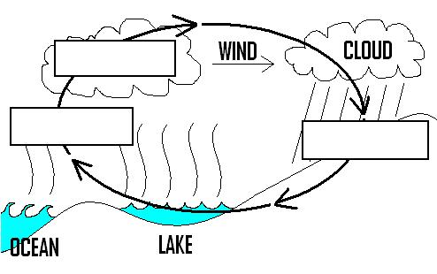

- Engineers need to learn about energy flow through a system to develop new technologies.
(circle one) True or False

