Energy & Nutrient Flow Concept Quiz Answers

- Which of the following is an example of an environment?
  - Evaporation
  - Tropical rain forest
  - Buoyancy
  - Ecology
- A biodome is:
  - A rock group
  - A space station
TeachEngineering.org – Free STEM Curriculum for K-12
  - A self-contained environment
  - A wildlife refuge
- Label the following as producers or consumers in the food chain.


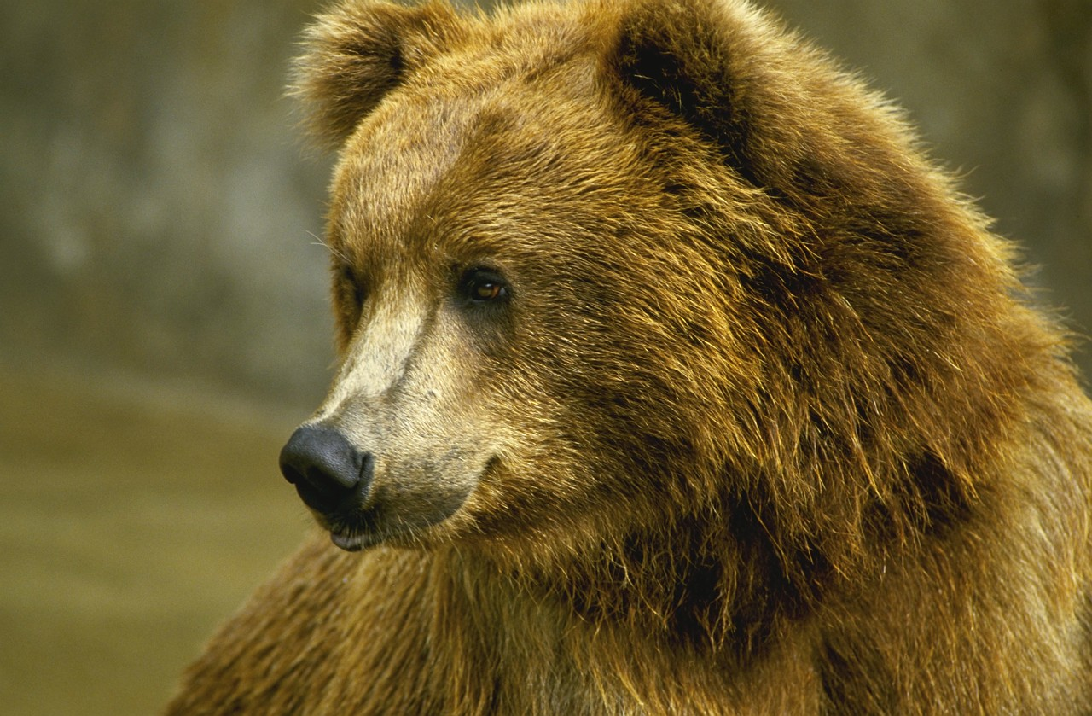

Consumer Producer Both Producer Consumer
- In the boxes below, fill in the three main stages of the water cycle: evaporation, precipitation, condensation.
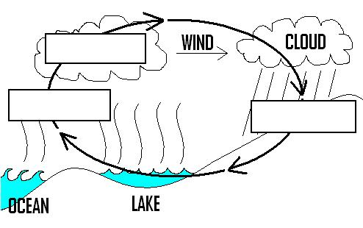
Condensation

Precipitation
Evaporation

- Engineers need to learn about energy flow through a system to develop new technologies.
(circle one) True or False
Clip art: Copyright © 2004 Microsoft Corporation, One Microsoft Way, Redmond, WA 98052-6399 USA. All rights reserved.
Water cycle graphic: Copyright © Mindy Zarske, ITL Program, College of Engineering, University of Colorado at Boulder, 2006. All rights reserved.

