. Jaipur Prosthesis
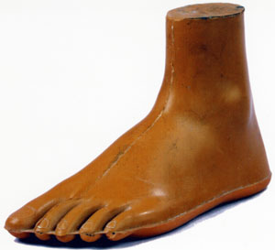
The Jaipur foot and below-knee prosthesis is low-cost, durable, waterproof, and can be used with or without shoes. A craftsman and an orthopedic surgeon designed this improved version of a conventional prosthetic foot. Named for the town in India where it was designed, the Jaipur foot is flexible along multiple axes, which allows natural movement of the foot. The Jaipur foot technology is based on traditional craft using small local production methods, and has already helped more than 900,000 amputees in developing and landmine-affected countries.
TeachEngineering.org – Free STEM Curriculum for K-12
Designers: Master Ram Chandra Sharma and Dr. P. K. Sethi
Manufacturer: Bhagwan Mahavir Viklang Sahayata Samiti, Jaipur, India, 1968
Materials: Micro-cellular rubber, cosmetic rubber compound, nylon cord rubber, trade rubber compound, cushion rubber compound, wooden keel with a connection bolt (foot); H.D.P.E. pipe, H.D.P.E. sheet, Jaipur foot, padeline sheet, leather straps (below-knee) Dimensions: 9.5-inch (foot), 9-inch (instep), 9-inch (ball girth), 21-inch (below-knee), 19.5-inch (maximum diameter)
In use in: Afghanisthan, Bangladesh, Dominican Republic, Honduras, Indonesia, Malawi, Nigeria, Nepal, Nairobi, Panama, Philippines, Papua New Guinea, Rwanda, Somalia, Trinidad, Vietnam, Zimbabwe, Sudan
Source: Cooper-Hewitt National Design Museum, New York, NY, Design for the Other 90% Exhibit, http://other90.cooperhewitt.org/Design/jaipur-foot-and-below-knee-prosthesis, Accessed October 9, 2008.
More information at: Jaipurfoot.org: http://www.jaipurfoot.org/

