

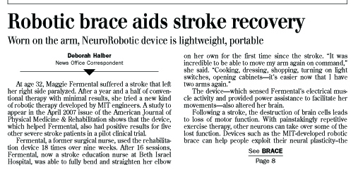

TeachEngineering.org – Free STEM Curriculum for K-12

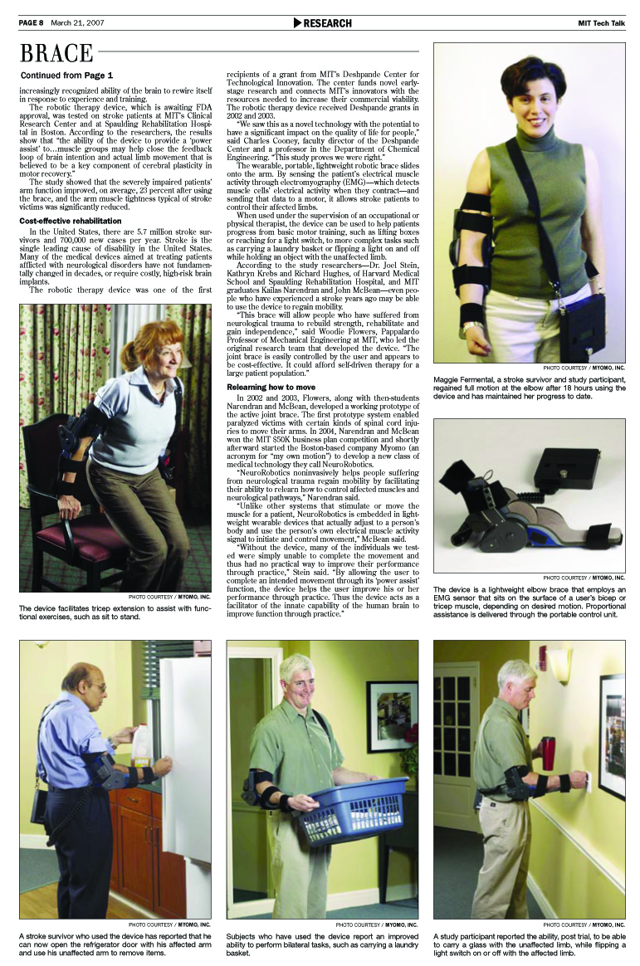



***Article source:*** Halber, Deborah. Robotic Brace Aids Stroke Recovery: Worn on the Arm, NeuroRobotic Device is Lightweight, Portable. Published March 21, 2007. *TechTalk*: Serving the MIT Community, Vol. 51, No. 22, MIT News Office, Massachusetts Institute of Technology. Accessed November 18, 2008. Used with permission. <http://web.mit.edu/newsoffice/2007/techtalk51-21.pdf> and <http://web.mit.edu/newsoffice/2007/brace.html>

***Images source:*** Myomo,Inc., <http://www.myomo.com/>. Used with permission.