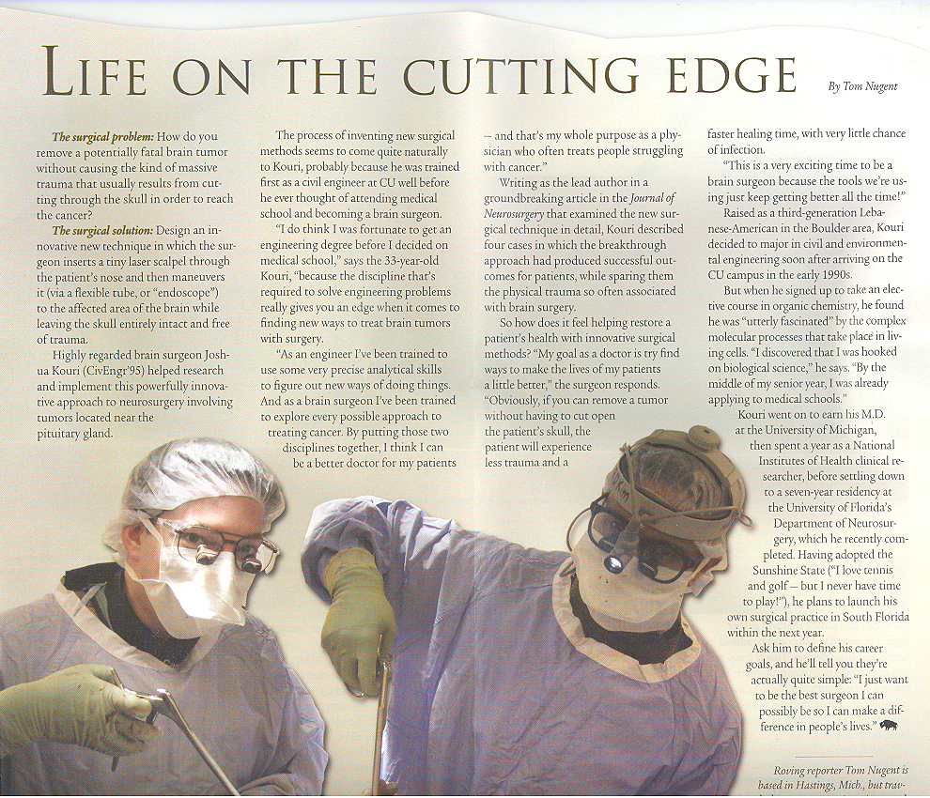
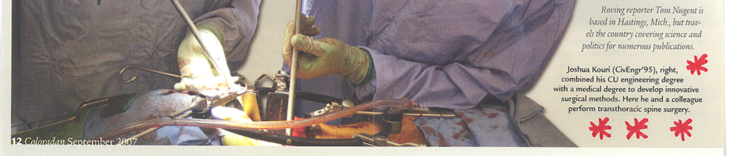
TeachEngineering.org – Free STEM Curriculum for K-12

Copyright © Tom Nugent, Coloradan, University of Colorado Alumni Association, 2007. Used with permission.

