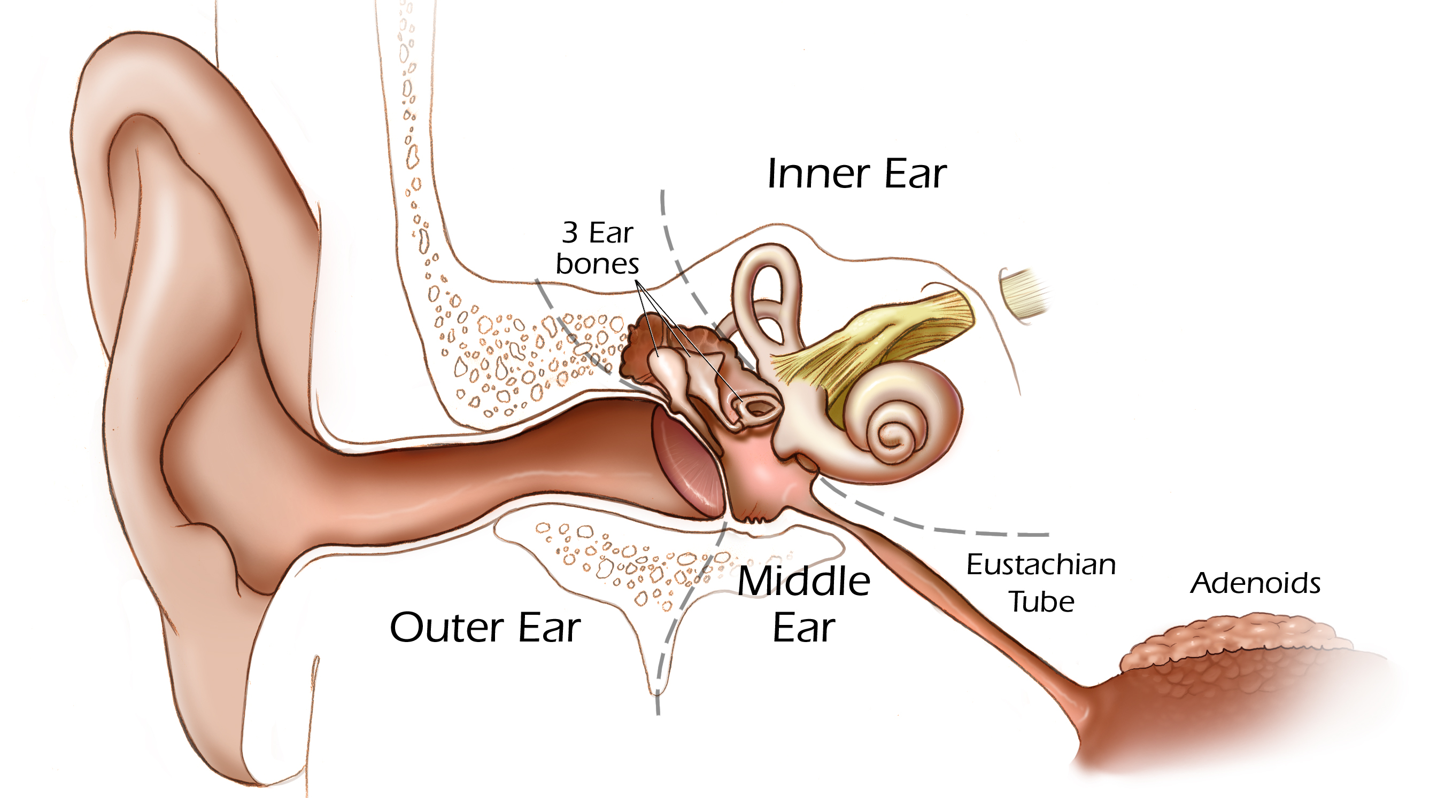
What’s in Your Ear? Worksheet

2
3
4
5
1

TeachEngineering.org – Free STEM Curriculum for K-12

- Fill the empty boxes in the above diagram with the correct identifying terms. Choose from the following possible terms:
outer ear ear lobe wind pipe
capillaries pinna middle ear
jaw bone inner ear ear canal
- Match the numbers on the above diagram with the correct terms, below.
_____ cochlea
_____ tympanic membrane (ear drum)
_____ malleus
_____ stapes
_____ incus
- Draw a line to match the hearing aid terms on the left to the correct definition on the right.
microphone Increases the amplitude, or strength, of the impulse
receiver Converts the electrical impulses created by the microphone back into sound waves and directs them into the ear canal.
amplifier Gathers sound waves and converts them to electrical impulses.

