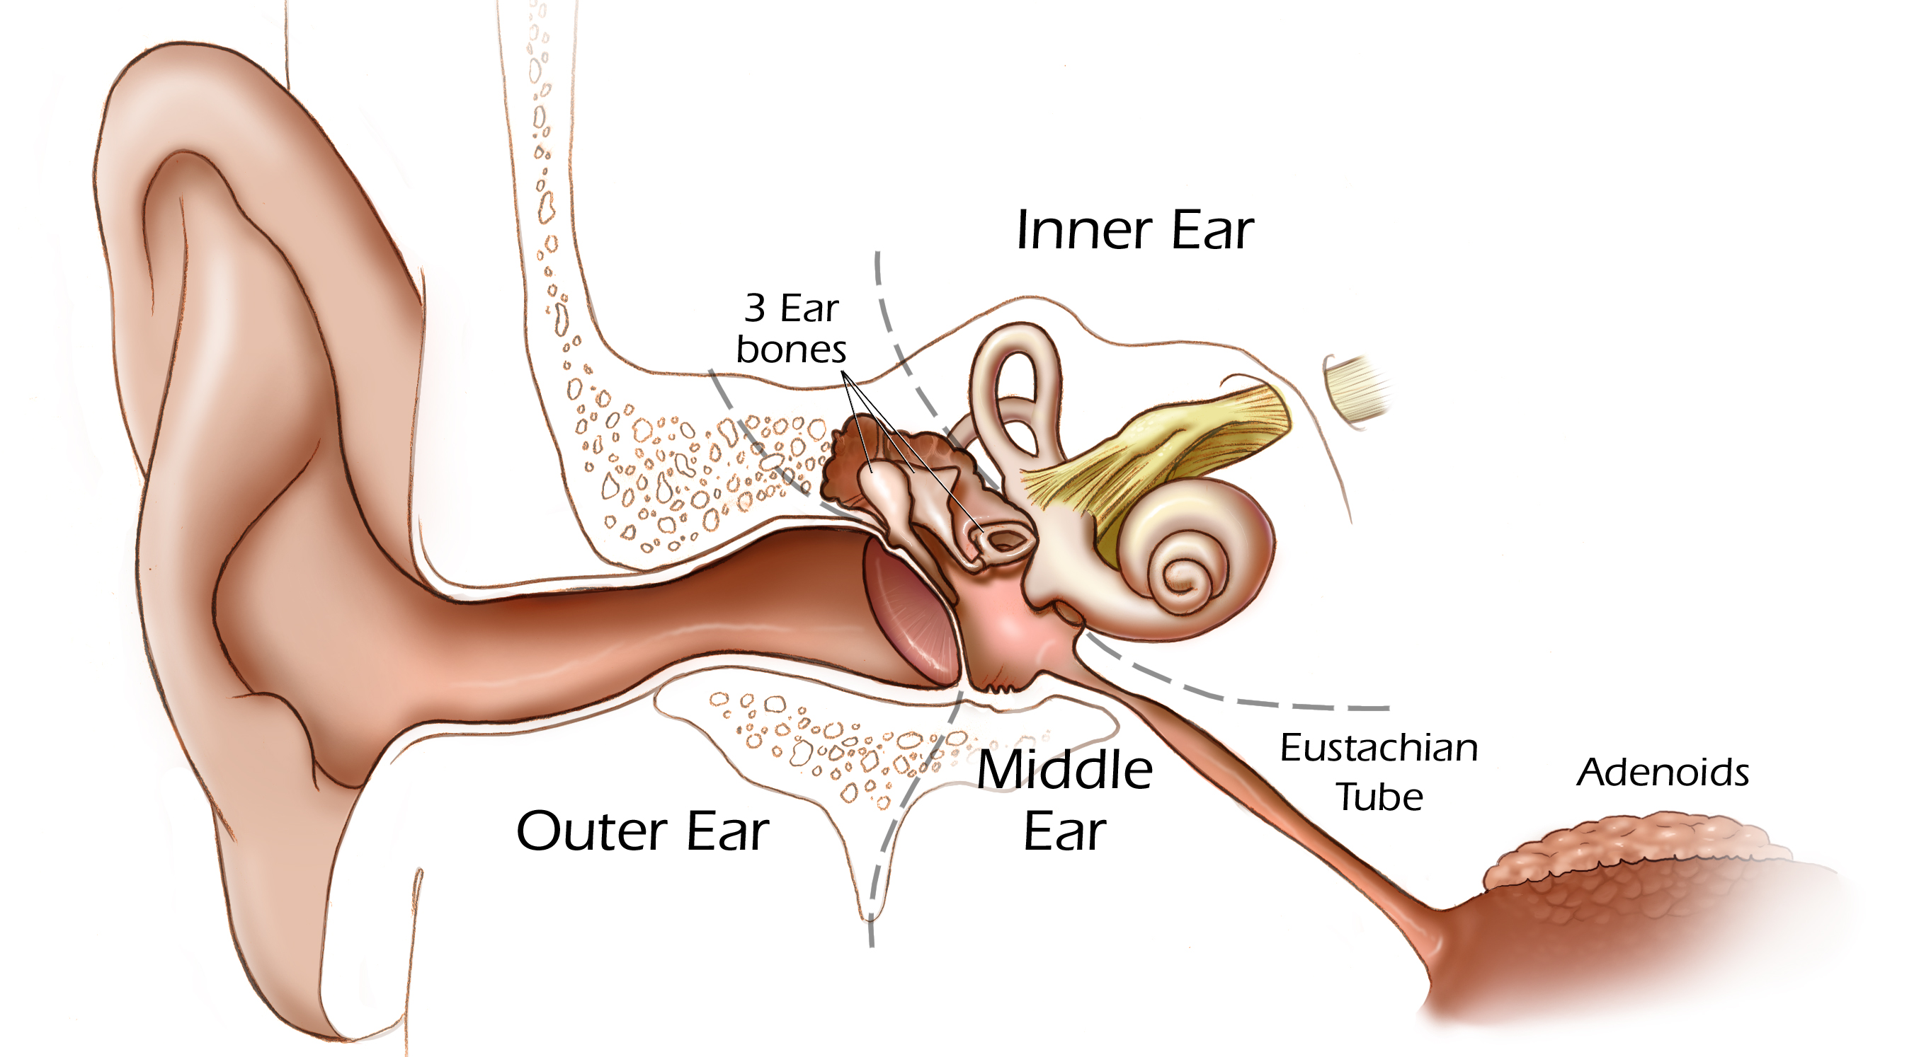
What’s in Your Ear? Worksheet Answers

pinna
2
3
4
5
1

TeachEngineering.org – Free STEM Curriculum for K-12

ear canal
inner ear

ear lobe

middle ear
ear
outer ear
- Fill the empty boxes in the above diagram with the correct identifying terms. Choose from the following possible terms:
outer ear ear lobe wind pipe
capillaries pinna middle ear
jaw bone inner ear ear canal
- Match the numbers on the above diagram with the correct terms, below.
___5__ cochlea
___1__ tympanic membrane (ear drum)
___2__ malleus
___4__ stapes
___3__ incus
- Draw a line to match the hearing aid terms on the left to the correct definition on the right.
microphone Increases the amplitude, or strength, of the impulse
receiver Converts the electrical impulses created by the microphone back into sound waves and directs them into the ear canal.
amplifier Gathers sound waves and converts them to electrical impulses.

