Ultrasound Image
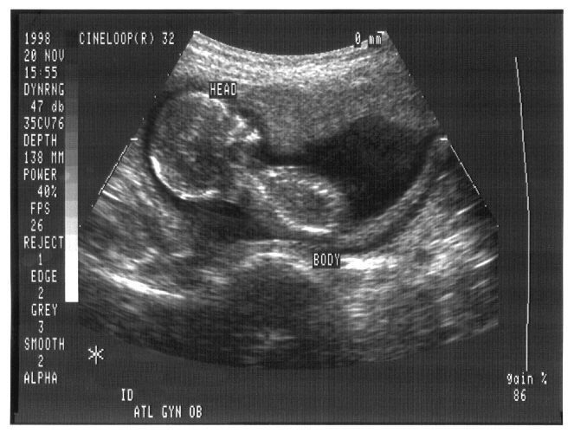
Ultrasound image of human fetus at four months.

TeachEngineering.org – Free STEM Curriculum for K-12

Source: Copyright © Jim Gathany, Public Health Image Library, Centers for Disease Control and Prevention,
US Department of Health and Human Services, http://phil.cdc.gov/PHIL_Images/04182000/00005/Ultrasound_lores.jpg

