Bones Quiz
- Fill in the blanks, labeling the different types of fracture repair seen below:
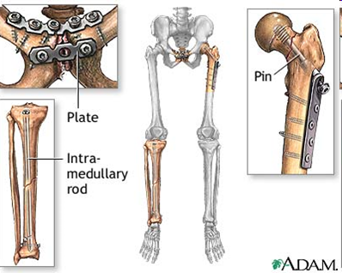

_____

TeachEngineering.org – Free STEM Curriculum for K-12
_______

_______

- Are these examples of internal fixation or external fixation? Circle one.
- Define the following terms, and give examples:
Biocompatibility:

Bone graft:

External fixation:

