Bones Quiz Answers
- Fill in the blanks, labeling the different types of fracture repair seen below:
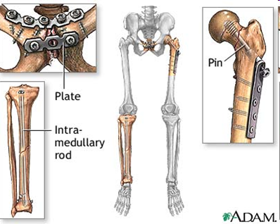

TeachEngineering.org – Free STEM Curriculum for K-12

- Are these examples of internal fixation or external fixation? Circle one.
- Define the following terms, and give examples:
Biocompatibility:
A characteristic of some materials that when they are inserted into the body do not produce a significant rejection or immune response. Examples: surgical stainless steels, titanium alloys and polymers.

Bone graft:
When bone is surgically taken from one place on a patient’s body and used to replace removed or damaged bone in another part of the patient’s body. Example: Take bone graft from a hip to replace damaged bone in spine.

External fixation:
External fixation is providing temporary repair supports outside of the skin to stabilize and align broken bones while the body heals. These can be externally adjusted. Examples: screws in a bone, metal braces, casts, slings.

