**Load Combinations Worksheet**



Show your work as you use the following load combinations to solve the problem.

**Load Combinations**

1. **Ultimate load = dead load + live load + snow load**
2. **Ultimate load = dead load + live load + wind load (or earthquake load)**
3. **Ultimate load = dead load + live load + wind load + (snow load ÷ 2)**
4. **Ultimate load = dead load + live load + snow load + (wind load ÷ 2)**
5. **Ultimate load = dead load + live load + snow load + earthquake load**

**Calculate the five ultimate loads resulting from each combination for the following loads:**

Dead load = 100,000 lbs

Live load = 30,500 lbs

Wind load = 5,020 lbs

Snow load = 400 lbs

Earthquake load = 5,000 lbs

**From the five ultimate loads calculated above, for which ultimate load amount must the structure be designed?**

**Problem 1: Using the highest load calculated from the first page, calculate the required area of a rectangular shape made of concrete if it is a pier or a column with a compression force acting on it. If L = 10 inches, what must B be equal to?**

The maximum compressive strength of this concrete is 4,000 lbs/in2. Use the following equations to complete the problem. Show all work and calculations.

Highest ultimate load = (max. compressive strength) x (cross-sectional area)

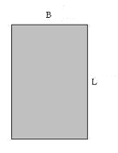Cross-sectional area = (B) x (L)

**B**

**L**

**Problem 1 cross-sectional area.**

**Problem 2A: Using the highest load calculated from the first page, calculate the required area of the circular shape made of concrete if it is a pier or a column with a compression force acting on it. What is the radius of this circle? The maximum compressive strength of this concrete is 5,000 lbs/in2.**

**Problem 2B: Using the highest load calculated from the first page, calculate the required cross sectional area of the I-shape made of steel if it is a pier or a column with a tension force acting on it. The maximum tensile strength of this steel is 50,000 lbs/in2.**

Use the following equations to complete the problem. Show all work and calculations.

Highest ultimate load = (max. compressive strength) x (cross-sectional area)

Cross-sectional area of circle = π x (radius)2 π = 3.14

Highest ultimate load = (max. compressive strength) x (cross-sectional area)

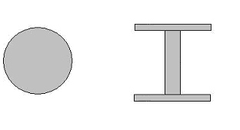

**Problem 2 cross-sectional areas.**

**Problem 3A: Using the highest load calculated from the first page, calculate the required Zx of the rectangular shape made of steel if it is a beam or a girder with a length equal to 20 feet (or 240 inches). Fy of steel is equal to 50,000 lbs/in2.**

**Problem 3B: What if the same beam was made of concrete with Fy equal to 4,000 lbs/in2.**

Use the following equations to complete the problem. Show all work and calculations.

Zx = (force x length) ÷ (Fy x 4)

**B**



**L**

**Problem 3 cross-sectional area.**