Strength of Materials Math Worksheet
- Calculate the maximum tensile and compressive forces allowed for the cross-sectional area shown in Figure 1. The maximum tensile strength is 500 lb/in² (pounds per inches squared). The maximum compressive strength is 5,000 lb/in². Use the following equations to complete the problem. Show your work and calculations.
cross-sectional area = (B) x (L)
maximum tensile force = (maximum tensile strength) x (cross-sectional area)
maximum compressive force = (maximum compressive strength) x (cross-sectional area)
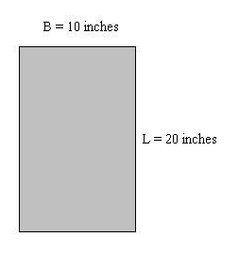
TeachEngineering.org – Free STEM Curriculum for K-12
Figure 1: Cross-sectional area.

- Calculate the maximum tensile and compressive forces allowed for the following two cross-sectional areas shown in Figure 2. The maximum tensile strength is 3,750 lb/in². The maximum compressive strength is 4,850 lb/in². Use the following equations along with those in #2 to complete the problem. Show your work and calculations.
cross-sectional area = π x (radius)² π = 3.14
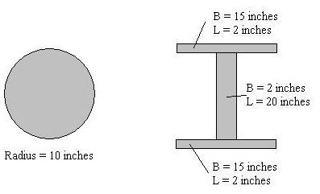
Figure 2: Cross-sectional areas.
- Part 1: Calculate the compressive force for the cross-sectional area shown in Figure 3. The original length of the member was 100-in long. After applying the compressive force, the member was 99-in long. The modulus of elasticity for the material used in the cross section is 10,000 lb/in². Use the following equations along with those in #2 and #3 to complete the problem. Show your work and calculations.

Part 2: Calculate the tension force for the cross-sectional area shown in Figure 3. The original length of the member was 100-in long. After applying the tensile force, the member was 103-in long. The modulus of elasticity for the material used in the cross section is the same as in #2 above. Use the following equations along with those in #2 and #3 to complete the problem. Show your work and calculations.
σ = E * ε σ = stress
ε = change in length / original length ε = strain
E = modulus of elasticity
change in length = (length after force applied) – (original length)
If the change in length is negative, take the absolute value to get a positive number
force = σ * cross-sectional area
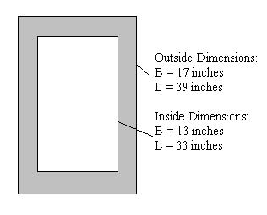
Figure 3: Cross-sectional area.

