Strength of Materials Math Worksheet Answers
- Calculate the maximum tensile and compressive forces allowed for the cross-sectional area shown in Figure 1. The maximum tensile strength is 500 lb/in² (pounds per inches squared). The maximum compressive strength is 5,000 lb/in². Use the following equations to complete the problem. Show your work and calculations.
cross-sectional area = (B) x (L)
maximum tensile force = (maximum tensile strength) x (cross-sectional area)
maximum compressive force = (maximum compressive strength) x (cross-sectional area)
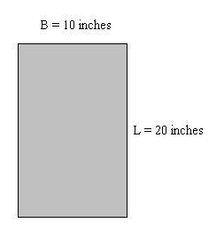
TeachEngineering.org – Free STEM Curriculum for K-12
Answer:
Cross-sectional area = (10 inches) x (20 inches) = 200 in²
Maximum tensile force = (500 lb/in²) x (200 in²) = 100,000 lb
Maximum compressive force = (5,000 lb/in²) x (200 in²) = 1,000,000 lbs
Figure 1: Cross-sectional area.

- Calculate the maximum tensile and compressive forces allowed for the following two cross-sectional areas shown in Figure 2. The maximum tensile strength is 3,750 lb/in². The maximum compressive strength is 4,850 lb/in². Use the following equations along with those in #2 to complete the problem. Show your work and calculations.
cross-sectional area = π x (radius)² π = 3.14
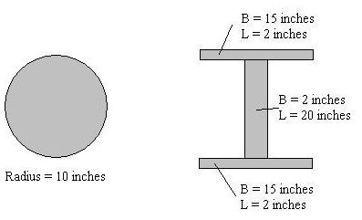
Answer:
Cross-sectional area of circle = 3.14 x (10 inches)² = 314 in²
Cross-sectional area of I-beam = (15 inches) x (2 inches) + (15 inches) x (2 inches) + (2 inches) x (20 inches) = 100 in²
Maximum tensile force of circle = (3,750 lb/in²) * (314 in²) = 1,177,500 lb
Maximum compressive force of circle = (4,850 lb/in²) * (314 in²) = 1,522,900 lb
Maximum tensile force of I-beam = (3,750 lb/in²) x (100 in²) = 375,000 lb
Maximum compressive force of I-beam = (4,850 lb/in²) x (100 in²) = 485,000 lb

Figure 2: Cross-sectional areas.

- Part 1: Calculate the compressive force for the cross-sectional area shown in Figure 3. The original length of the member was 100-in long. After applying the compressive force, the member was 99-in long. The modulus of elasticity for the material used in the cross section is 10,000 lb/in². Use the following equations along with those in #2 and #3 to complete the problem. Show your work and calculations.

Part 2: Calculate the tension force for the cross-sectional area shown in Figure 3. The original length of the member was 100-in long. After applying the tensile force, the member was 103-in long. The modulus of elasticity for the material used in the cross section is the same as in #2 above. Use the following equations along with those in #2 and #3 to complete the problem. Show your work and calculations.
σ = E * ε σ = stress
ε = change in length / original length ε = strain
E = modulus of elasticity
change in length = (length after force applied) – (original length)
If the change in length is negative, take the absolute value to get a positive number
force = σ * cross-sectional area
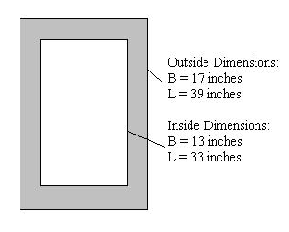
Figure 3: Cross-sectional area.
Part 1 Answer:
Change in length = 99 inches - 100 inches = -1 inch
Taking the absolute value, change in length = 1 inch
ε = 1 inch / 100 inches = 0.01
σ = (10,000 lb/in²) x (0.01) = 100 lb/in²
Cross-sectional area = (17 inches) x (39 inches) – (13 inches) x (33 inches) = 234 in²
Force = (100 lb/in²) x (234 in²) = 23,400 lb
Part 2 Answer:
Change in length = 103 - 100 inches = 3 inches
ε = 3 inches / 100 inches = 0.03
σ = (10,000 lb/in²) x (0.03) = 300 lb/in²
Cross-sectional area = (17 inches) x (39 inches) – (13 inches) x (33 inches) = 234 in²
Force = (300 lb/in²) x (234 in²) = 70,200 lb

