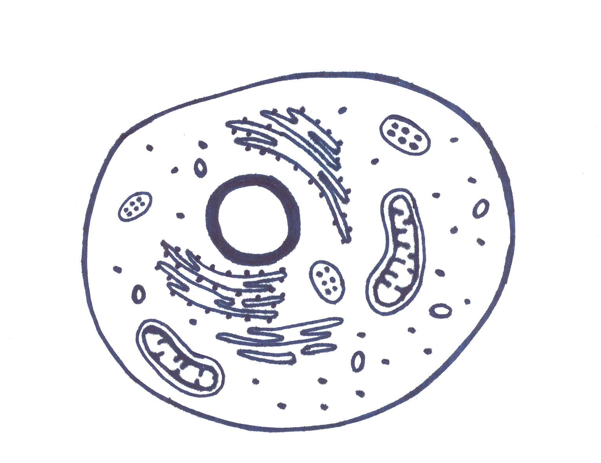
Eukaryote
Endoplasmic Reticulum
Nucleus
Mitochondria
Cell membrane
Ribosome
TeachEngineering.org – Free STEM Curriculum for K-12
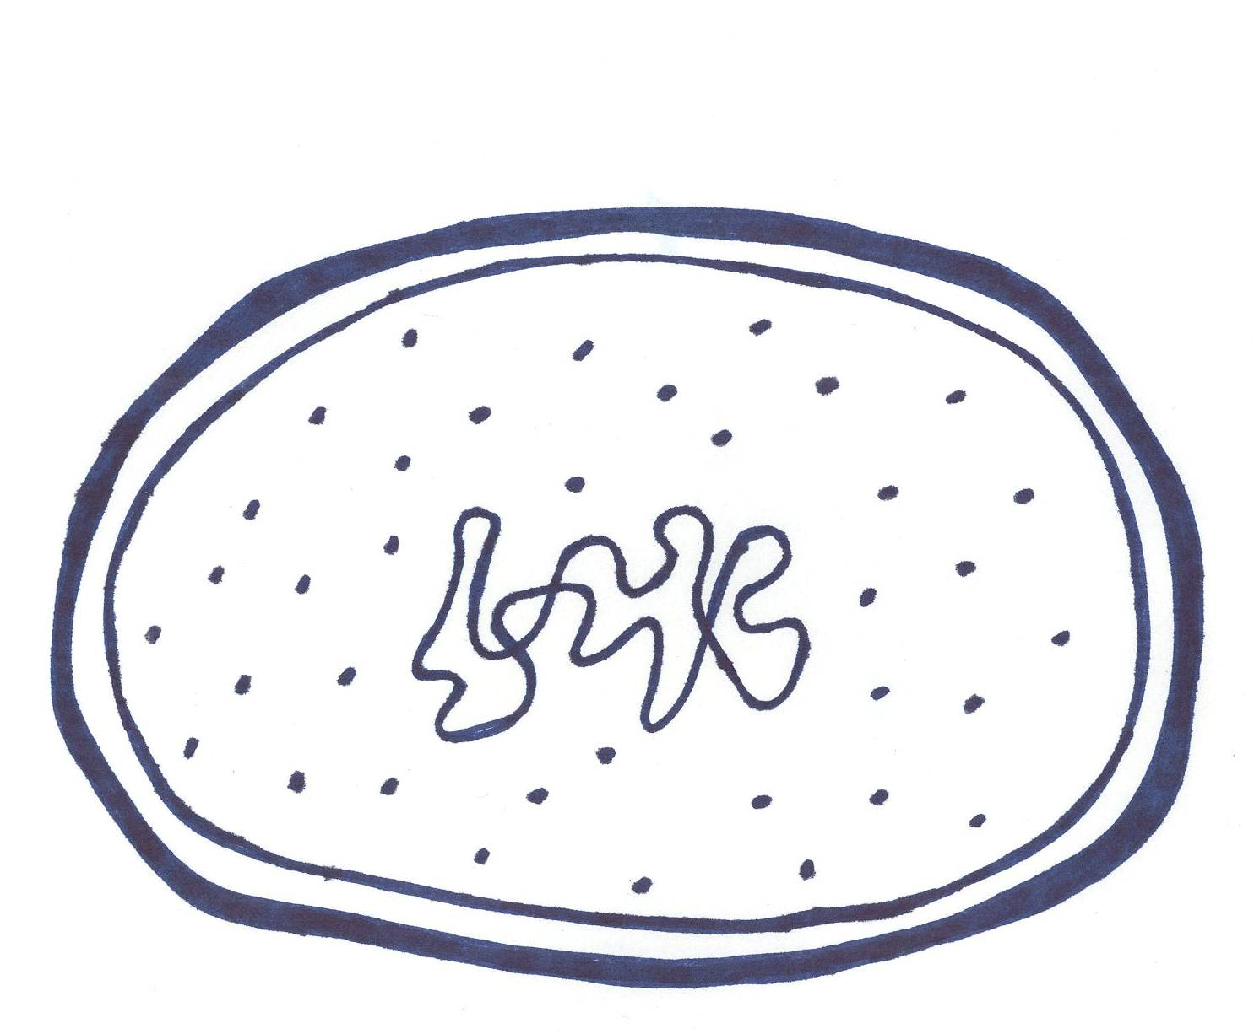
Prokaryote
Cell wall
Cell membrane
Ribosome
Cytoplasm
Nucleoid

