Cancer and HeLa Cells

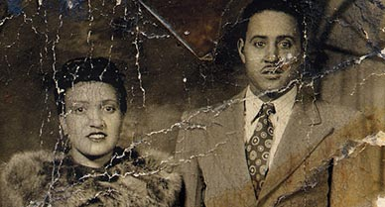

TeachEngineering.org – Free STEM Curriculum for K-12

Photograph from the 1940’s of Henrietta and David Lacks

**Source/Rights:** Copyright ©The Lacks Family, Wikimedia Commons, 2010

Cancer, on a cellular level, occurs when DNA is damaged or altered in a way that allows a cell to grow and divide without proper signals, such as external growth factors. This means that they no longer have inhibition, which is what causes normal cells to stop growing and dividing. Instead, they continue to undergo mitosis and produce more and more cells. This continued division leads to formation of tumors: lumps caused by the abnormal growths of cells. Much of the knowledge we have about cancer today has stemmed from research on what are called HeLa cells. HeLa cells are a direct line of living cancer cells that came from a woman who died more than fifty years ago.

Henrietta Lacks was born in Clover, Virginia on August 1, 1920. Henrietta was the descendant of slaves and grew up working the same fields, albeit as a share-cropper. When she was 21, she married her first cousin, David. Together, they had five children. When Henrietta was 31, she had her husband drive her to the free clinic at Johns Hopkins University, one of the only hospitals near their home that would treat “colored” people. There was a lump on her cervix that eventually proved to be cancer. A doctor named George Gey and his wife worked at the hospital at the time: they were trying to find a successful way to keep human cells alive for a period of time outside of the body, and had reached out to many doctors regarding cell samples. In fact, there was a bell on a cord that ran across the courtyard to the obstetrics ward so they could collect samples from each newborn’s umbilical cord. Many doctors brought Gey samples from their patients, but most patients did not know what was happening with their tissue. The issue of informed consent (agreement given based on understanding of facts, consequences, and future implications of a decision) had not been raised: it was just common practice at the time. Henrietta’s doctor sent a sliver of her tumor to Gey: to everyone’s surprise (and without Henrietta’s knowledge) her cells survived and divided rapidly. Gey distributed Henrietta’s cells, now named “HeLa” for her name, to any doctor that asked for them, at no cost. Henrietta died on October 4, 1951.

HeLa cells are the first natural human immortal cell line, and they have been used for research in just about every field of biology. They allowed Jonas Salk to cheaply and easily test his polio vaccine; they were sent into space and discovered to grow faster in zero gravity; they were the basis for the field of virology; they have been used in AIDS and cancer research; they have been used to test human sensitivity to glue and cosmetic products; the list goes on and on. In fact, the fields of biomedical engineering and public health could have been dramatically different without the use of HeLa cells.

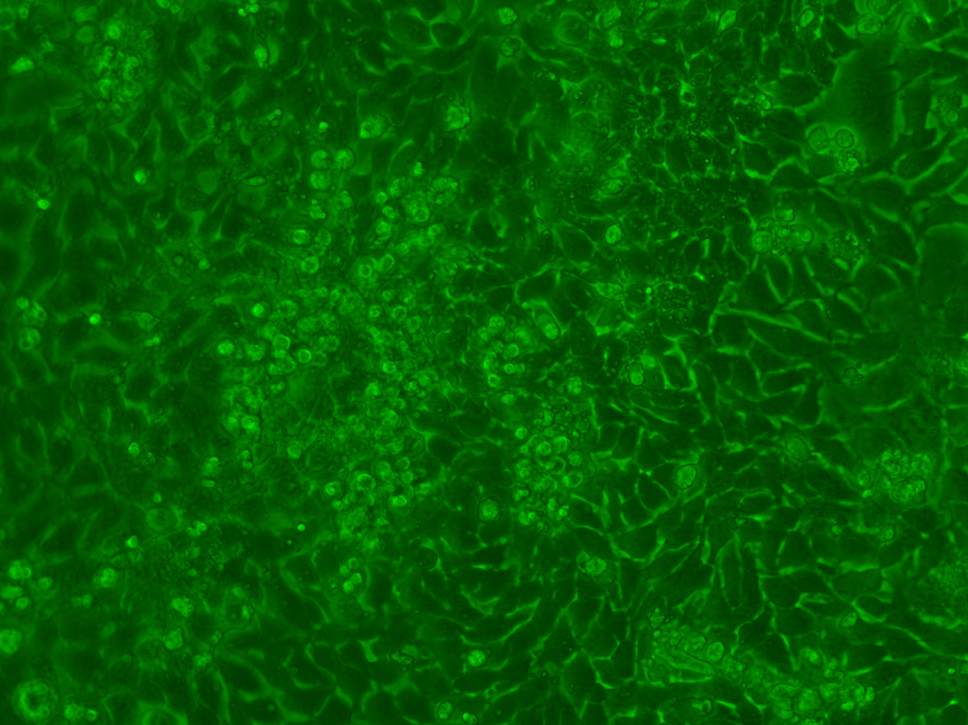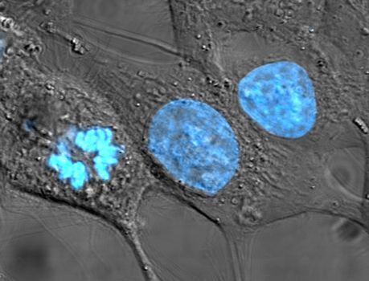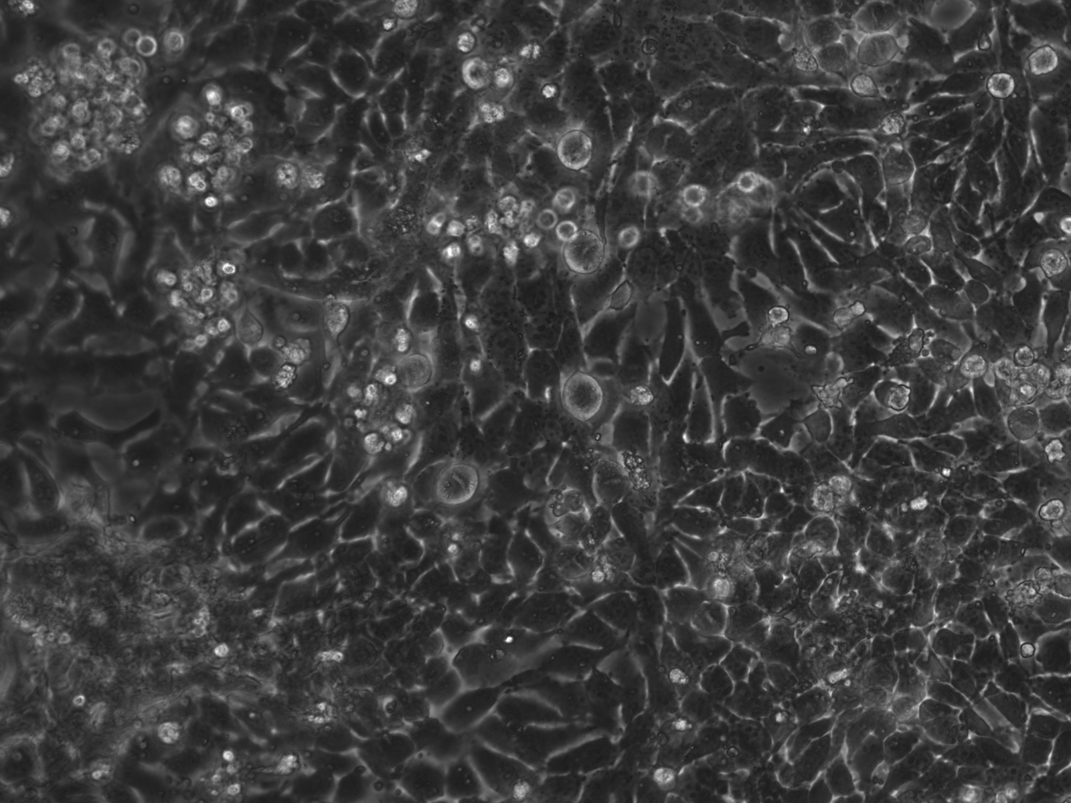

A microscopic view of HeLa cells at a green wavelength emission

**Source/Rights:** Copyright © Megan Shaw

A microscopic vew of HeLa cells with blue staining

**Source/Rights:** Copyright © TenOfAllTrades, released into public domain

HeLa cells under a microscope

**Source/Rights:** Copyright © Megan Shaw