Learning about Renewable Energy
What is renewable energy?
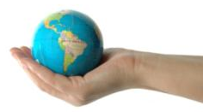

List five different types of renewable energy:
1.
2.
3.
TeachEngineering.org – Free STEM Curriculum for K-12
4.
5.
How does choosing to use renewable energy help the Earth?

How does the use of renewable energy help people’s health?

List two solid fuels and two non-solid fuels.
Explain one way in which these fuel types are different.

Explain how the use of solid fuels can be harmful to people’s health.

Vocabulary Words to Know

renewable
non-renewable
wind
water
solar
biomass
geothermal
pollution
energy
emissions
global warming
climate change

