Force and Pressure Quiz
- Which would exert a higher force on a scale: A grown elephant or a baby elephant? Why?
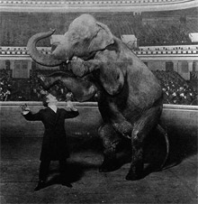
A grown elephant would exert a higher force because it has a greater mass than a baby elephant. Since force is measured as F = mass * acceleration, and the acceleration due to gravity is the same for both elephants, the force is greater for the elephant with the greater mass.
TeachEngineering.org – Free STEM Curriculum for K-12

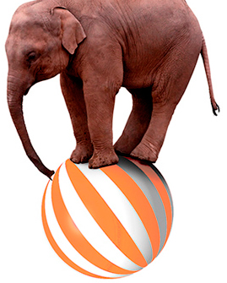
- Would an elephant standing on one leg exert a higher force on a scale than an elephant standing on four legs? Why?

The force exerted on the scale would be equal because Force = mass * acceleration. Since both masses are the same and the acceleration due to gravity is the same for both cases, the forces are equal.

- Would an elephant standing on one leg exert a higher pressure on the scale than an elephant standing on all four legs?

The elephant standing on one leg would exert a greater pressure than the elephant standing on all four legs. This is because Pressure = Force/Area. The forces exerted in both cases are the same (see question 2), but since the area that the force is exerted over is smaller when the elephant is on one leg, the pressure is greater.

