How a Dam and Lock System Works
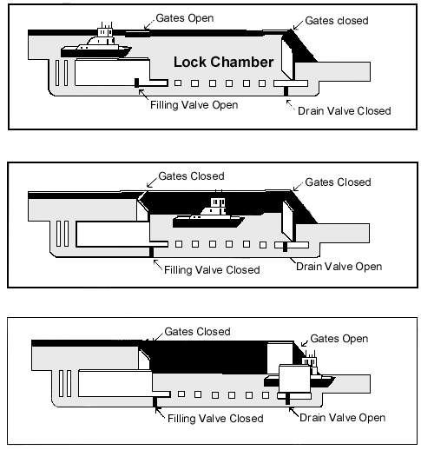

TeachEngineering.org – Free STEM Curriculum for K-12

To move a ship or boat going downstream to a lower water level, the lock is filled by opening the filling valve. Then the drain valve and upstream and downstream gates are closed so the chamber water level rises to the upstream level. Then upstream gate opens and the boat moves in. To lower the boat, the gates are closed behind it, the filling valve is closed, and the drain valve is opened. The higher water in the lock chamber drains to the downstream level in a few minutes. Then, the downstream gate is opened and the water vessel moves out on the lower water level. The process is reversed for a ship or boat going upstream.

Source: US Environmental Protection Agency, Gulf of Mexico Program, http://www.epa.gov/gmpo/edresources/locks.html

