Salmon Life Cycle
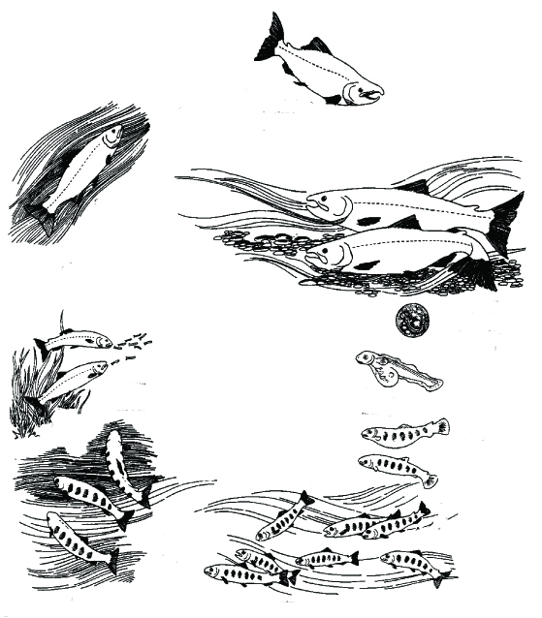
Adults change in form and color as they advance upstream to their birthplace to spawn

START
In the fall, female adult salmon each deposit thousands of eggs in stream bed gravel nests; eggs are fertilized by adult males
Mature, adult fish leave the ocean, return to the rivers, and swim upstream

TeachEngineering.org – Free STEM Curriculum for K-12

adult

egg
Newly-hatched salmon (alevins) have the yolk sack attached to them for food, and stay in the nest
Juveniles grow to maturity in the ocean, some travel great distances
alevin

fry or parr
juvenile
In the spring, fry (also called parr) emerge from the gravel nest to find food, and grow in the streams

smolt
Smolts migrate downstream, undergoing body changes so they can survive in the salty ocean

Question: A dam would most likely affect mature adult salmon when they are swimming upstream to their birthplace to spawn (reproduce). If a dam prevents them from reaching the area where they spawn, what happens to the salmon population?
Will it increase, decrease or stay the same?

Source of graphic: Life cycle of the Pacific salmon, 2-7 years, Alaska Department of Fish and Wildlife, http://www.sf.adfg.state.ak.us/region2/ie/sicc/salmon_p.cfm and Oregon Department of Fish and Wildlife “Stream Scene,” http://www.oregon.gov/OPSW/archives/streamscene/streamscene.shtml

