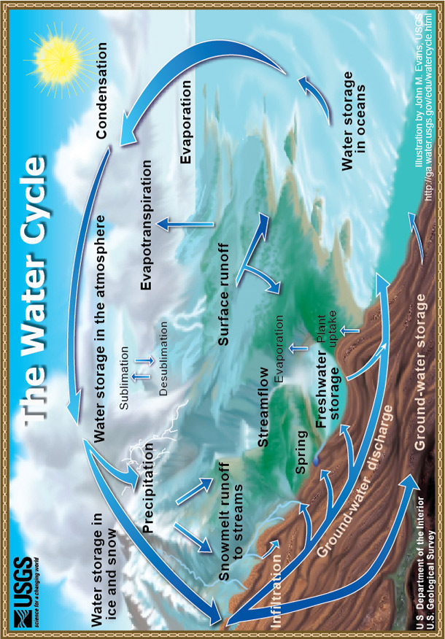

TeachEngineering.org – Free STEM Curriculum for K-12

Source: US Geological Service, http://ga.water.usgs.gov/edu/watercycleprint.html

