Water Desalination:
Design Your Own Desalination Plant
System Components
membrane
brine
cleanwater
saltwater
Membrane: This component takes in saltwater and pushes it though a membrane capable of removing salt ions. It produces clean water and brine.
evaporator
vapor
brine
saltwater

Evaporator: This component takes in saltwater and produces water vapor and brine.
TeachEngineering.org – Free STEM Curriculum for K-12

clean water tank
any clean water
Clean Water Tank: This component takes in any clean water produced.
waste tank
any waste water, brine
Waste Tank: This component takes in any unused saltwater and brine.
Condenser: This component takes in water vapor and produces water droplets.
condenser
vapor
clean water

Your Goal
Using the above system components, draw a system diagram for your water desalination plant. You can use the system components as many times as you want, but you must include a clean water tank and a waste tank.
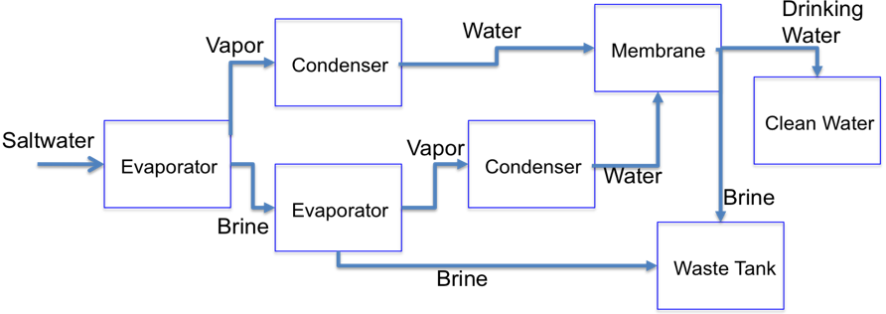
A correct design may be any diagram that follows a logical order, such as the following example.

