Detail Drawings Quiz
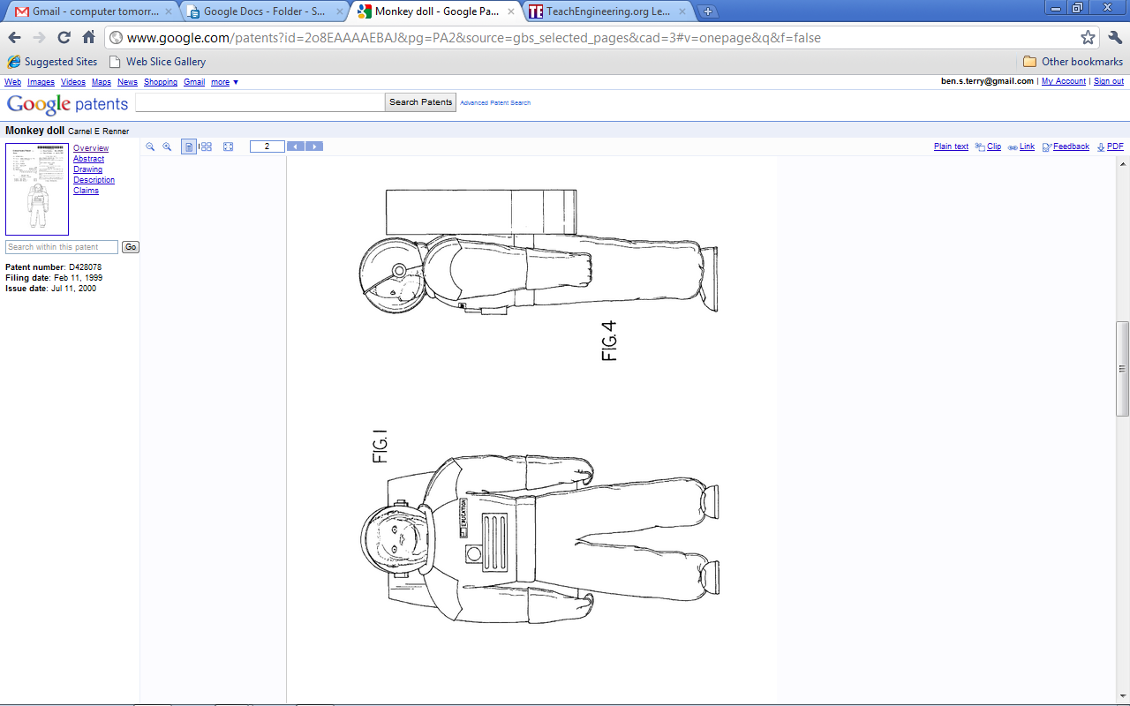
- The following two views are taken from U.S. patent filing Des. 428,078 (Monkey Doll).
Which views are shown?

TeachEngineering.org – Free STEM Curriculum for K-12

- The following three views are taken from U.S. patent filing 2,196,066 (Contact Lens).
Which views are shown?
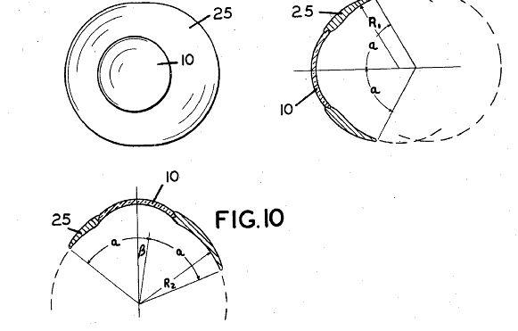

- The full standard for creating, dimensioning, and tolerancing detail drawings is rigidly controlled by a sizeable document titled, “ASME Y14.5 and ASME Y14.100 Dimensioning Tolerancing and Engineering Drawing Practices Package.” Learning the entire standard is similar to learning a foreign language! Explain why the rules and procedures for creating detail drawings are so comprehensive and thorough?

