Detail Drawings Quiz Answers
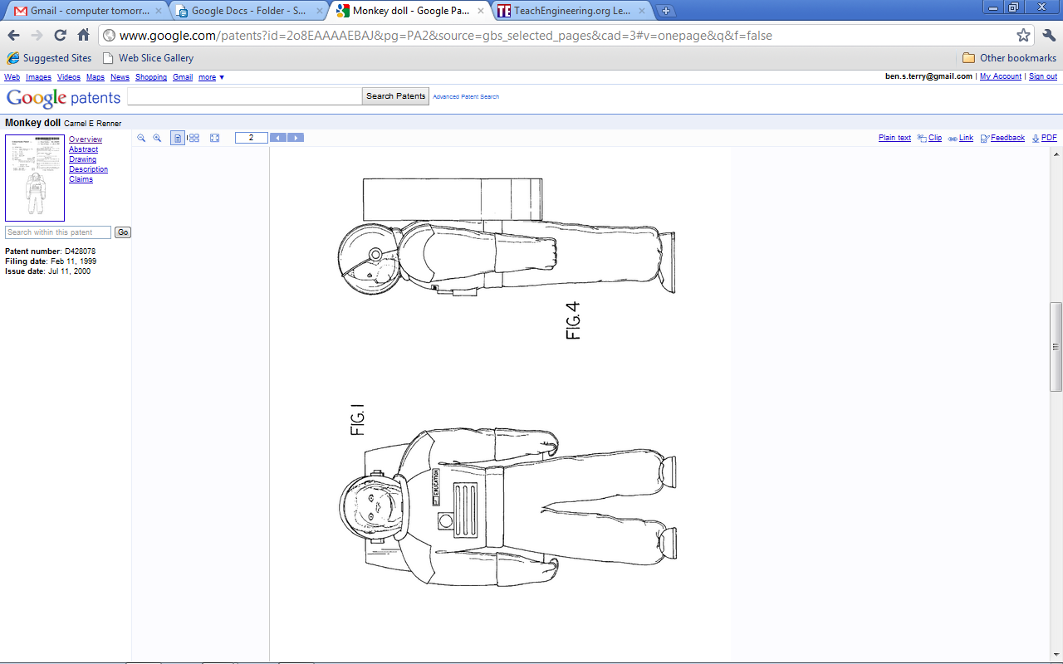
- The following two views are taken from U.S. patent filing Des. 428,078 (Monkey Doll).
Which views are shown? Two possible answers: 1) front and right, 2) front and left

TeachEngineering.org – Free STEM Curriculum for K-12

- The following three views are taken from U.S. patent filing 2,196,066 (Contact Lens).
Which views are shown? One possible answer: front, right, bottom
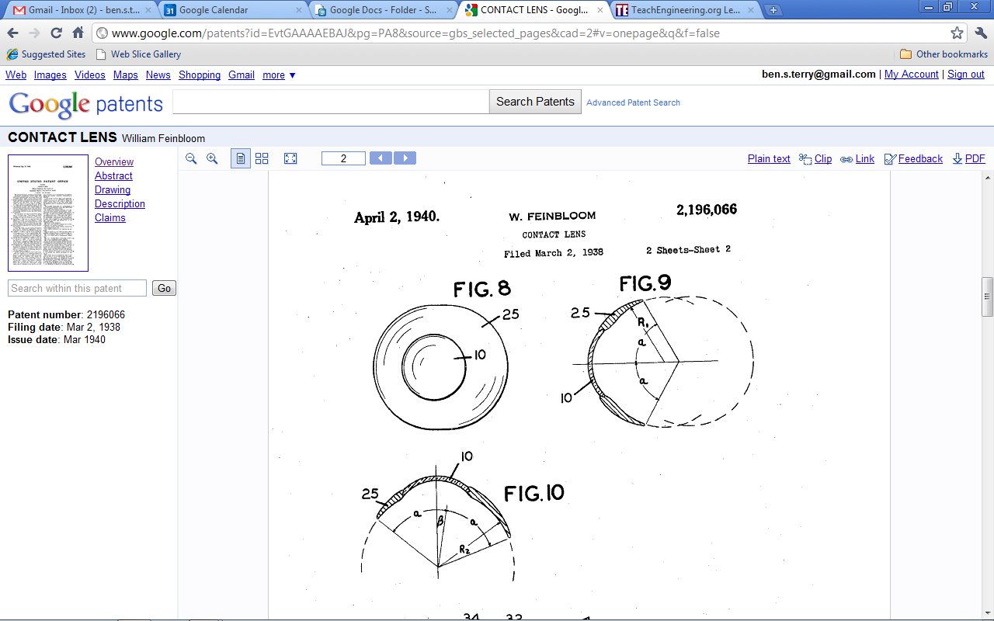
front
right

bottom
- The full standard for creating, dimensioning, and tolerancing detail drawings is rigidly controlled by a sizeable document titled, “ASME Y14.5 and ASME Y14.100 Dimensioning Tolerancing and Engineering Drawing Practices Package.” Learning the entire standard is similar to learning a foreign language! Explain why the rules and procedures for creating detail drawings are so comprehensive and thorough?
Possible answer: The reason they are so thorough is due to the open-ended nature of design. Engineers have nearly unlimited latitude in designing new products, some of which can be very complicated and detailed. The design intent must be precisely communicated to colleagues and manufacturers, therefore the rules and procedures guiding the design documents are also lengthy and detailed.

