You Are What You Drink
Research Worksheet
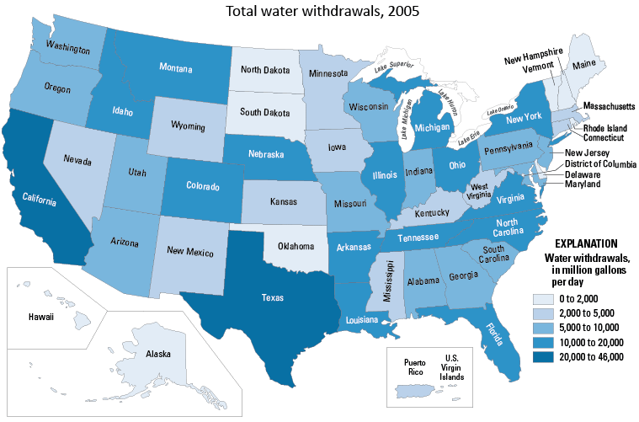
TeachEngineering.org – Free STEM Curriculum for K-12
TeachEngineering.org – Free STEM Curriculum for K-12

Choose one of the United States: ____________________________

Looking at the picture above, which color is that state? ______________________

What does that color mean? _____________________ million gallons per day
Research Time!
What is the population of your state?
The state population is ____________________________________________________
compared to the national population of 310 million people.
What are the major industries in the state?
The major industries are ____________________________________________________
_______________________________________________________________________.
In your own words...
How do you think the people and the industries in the state use water?
_______________________________________________________________________
_______________________________________________________________________.

