Launch Angle & Air Resistance
Worksheet Answers
- The image below shows the trajectory of an object launched from the cannon at 45 degrees and experienced no air resistance. Draw the trajectories of the same object with launch angles of 75, 60, 30, and 15 degrees.
Note to teachers: Students’ answers should be just approximates.
Look at their answers to make sure they understand the basic concepts.
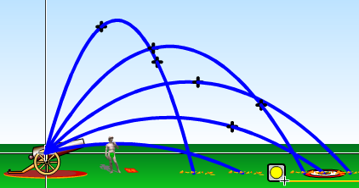
75°
TeachEngineering.org – Free STEM Curriculum for K-12
60°

45°
30°

15°

- The image below shows the trajectory of a t-shirt launched from the cannon at 45 degrees and experienced no air resistance. Draw the trajectories of a t-shirt with air resistance if: a) it is rolled up into a ball first and stays that way, and b) if it is not rolled into a ball.
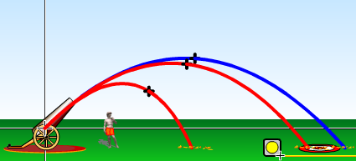

a
b

