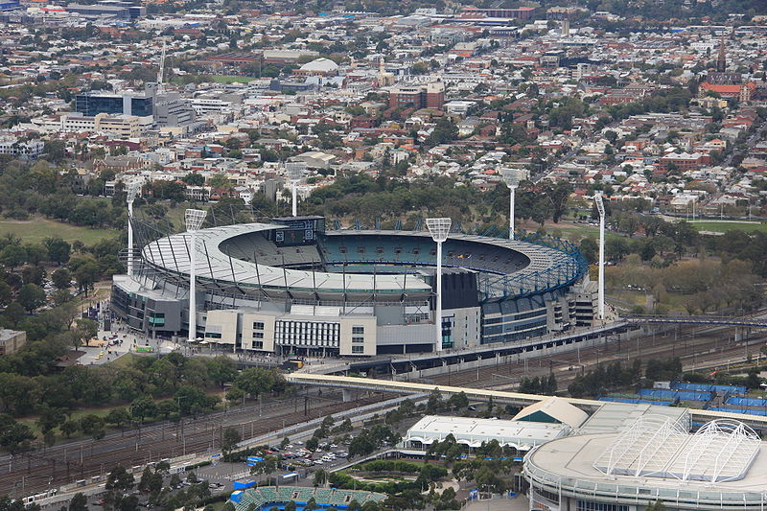**Stadiums**

TeachEngineering.org – Free STEM Curriculum for K-12

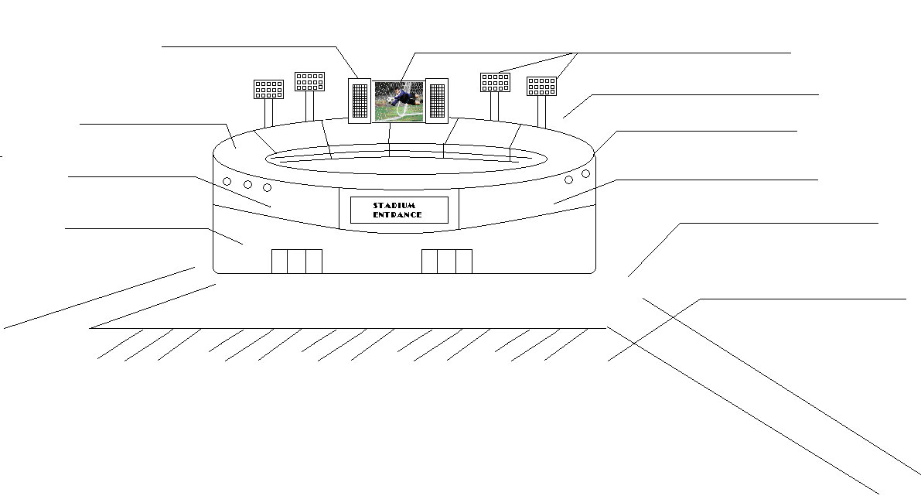

(top) Melbourne Cricket Ground, Australia © 2009 Adam J.W.C., Wikimedia Commons {PD} <http://commons.wikimedia.org/wiki/File:Mcg_melb.JPG>

Wembley Stadium (interior), England © 2007 jbmg40, Wikimedia Commons {PD} <http://commons.wikimedia.org/wiki/File:Wembley_Stadium_interior.jpg>

